CLOUDERA ON AWS

# CONTENT

1. INTRODUCTION
2. AMAZON EC2 SETUP – 4 NODE CLUSTER
3. PRE-STEPS for CLOUDERA INSTALLATION
4. INSTALLATION of CLOUDERA 5.X on EC2 USING CLOUDERA MANAGER
5. POST INSTALLATION STEPS
6. CLOUDERA MANAGER OVERVIEW
7. CONCLUSION

# INTRODUCTION

This section explains how to get Cloudera up and running using Cloudera Manager on Amazon Web Services (AWS) and you could follow the similar procedures for deploying Cloudera in other cloud services such as Google Cloud Platform, and Microsoft Azure.

# AMAZON EC2 SETUP – 4 NODE CLUSTER

To use Cloudera Director on AWS, you create an environment in Amazon Virtual Private Cloud (Amazon VPC), start an instance in AWS to run Cloudera Director, and create a secure connection. This section describes the steps for each of these tasks.

Login to your Amazon account and navigate to AWS EC2

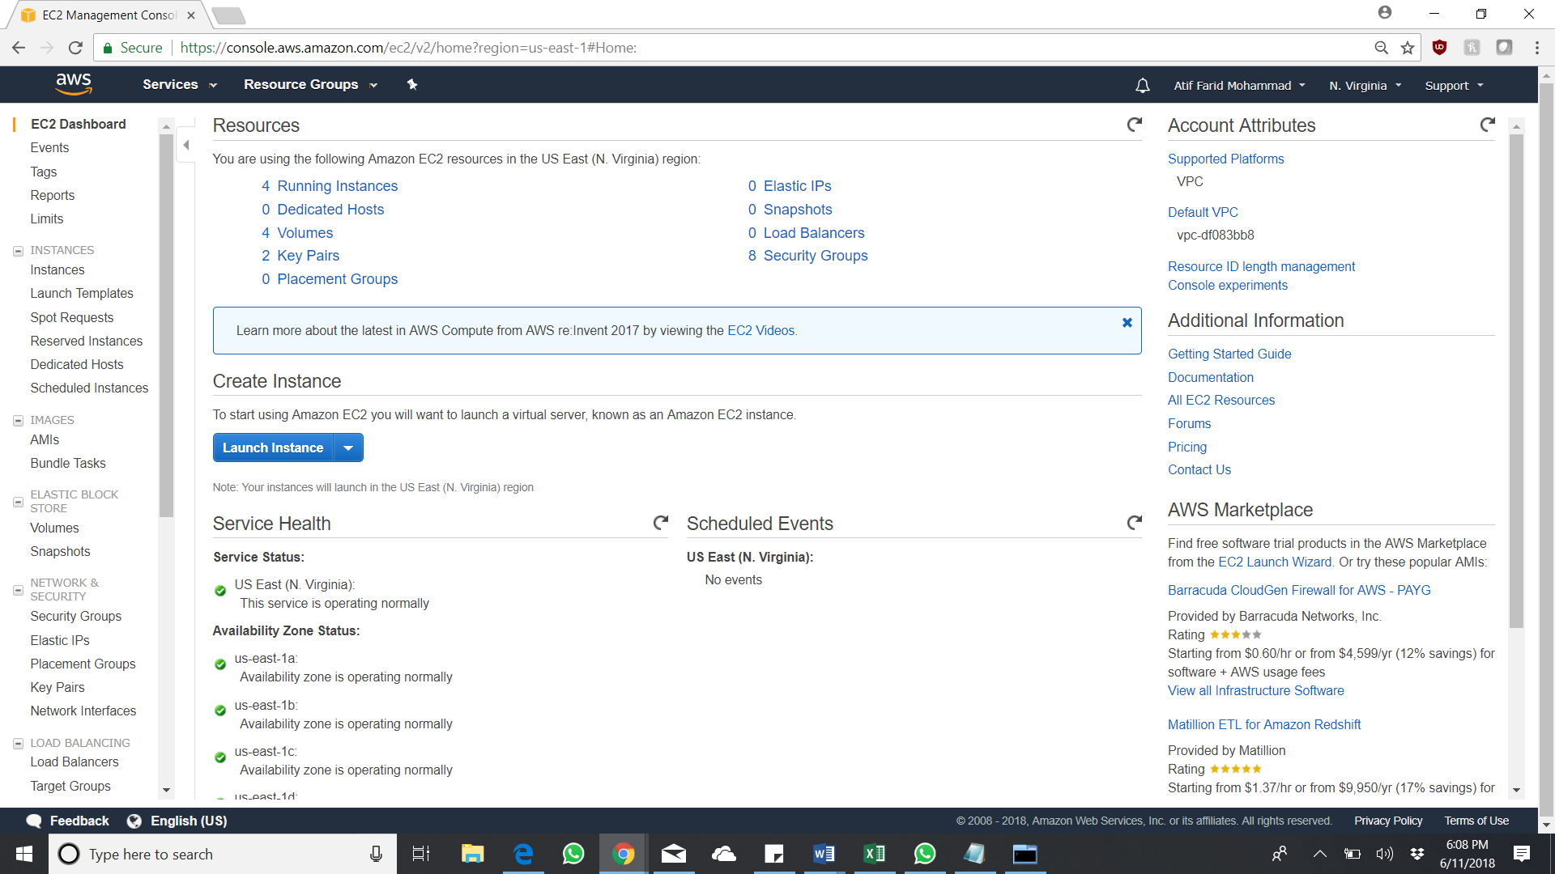

Launch and EC2 instance and choose Amazon Ubuntu Server 16.04 LTS (HVM), SSD Volume Type AMI

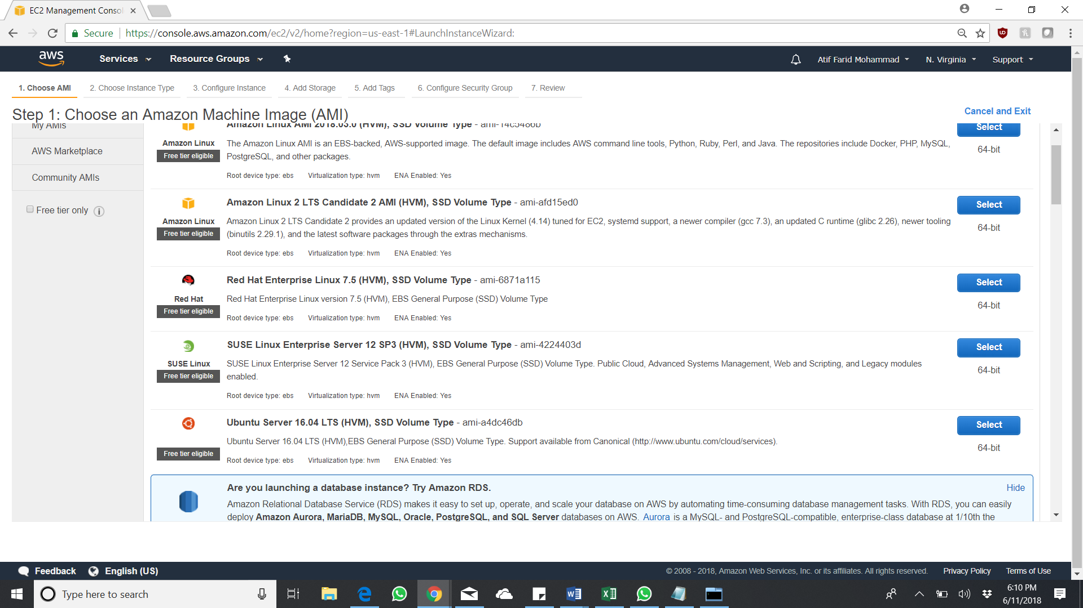

Choose Instance type based on your need, t2.micro is a free version from Amazon and hence I am going with it. But you are expecting to have a heavy load the go for the higher instances.

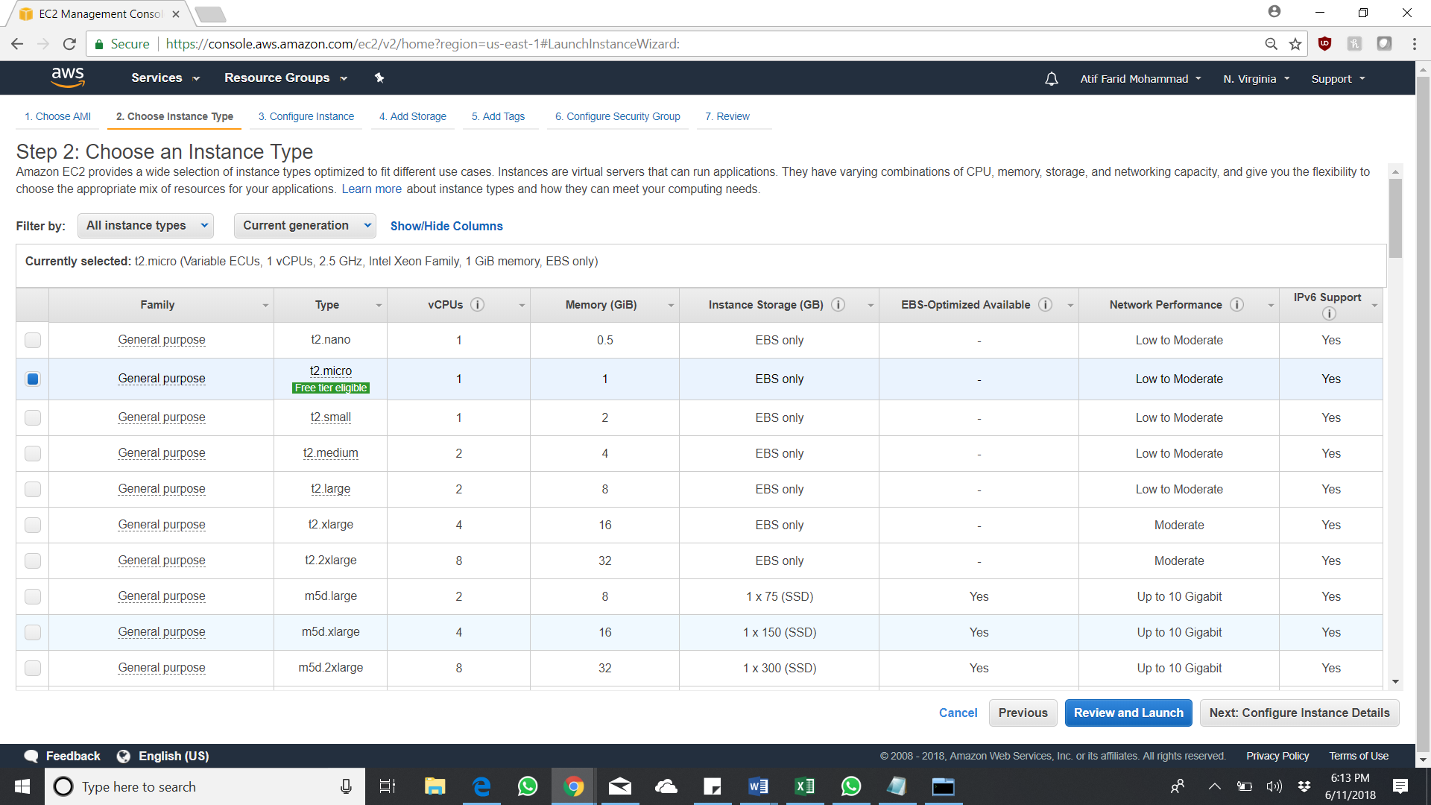

Number of instance – 4 as it is a 4node cluster, choose the respective VPC, Subnet and Enable Public IP

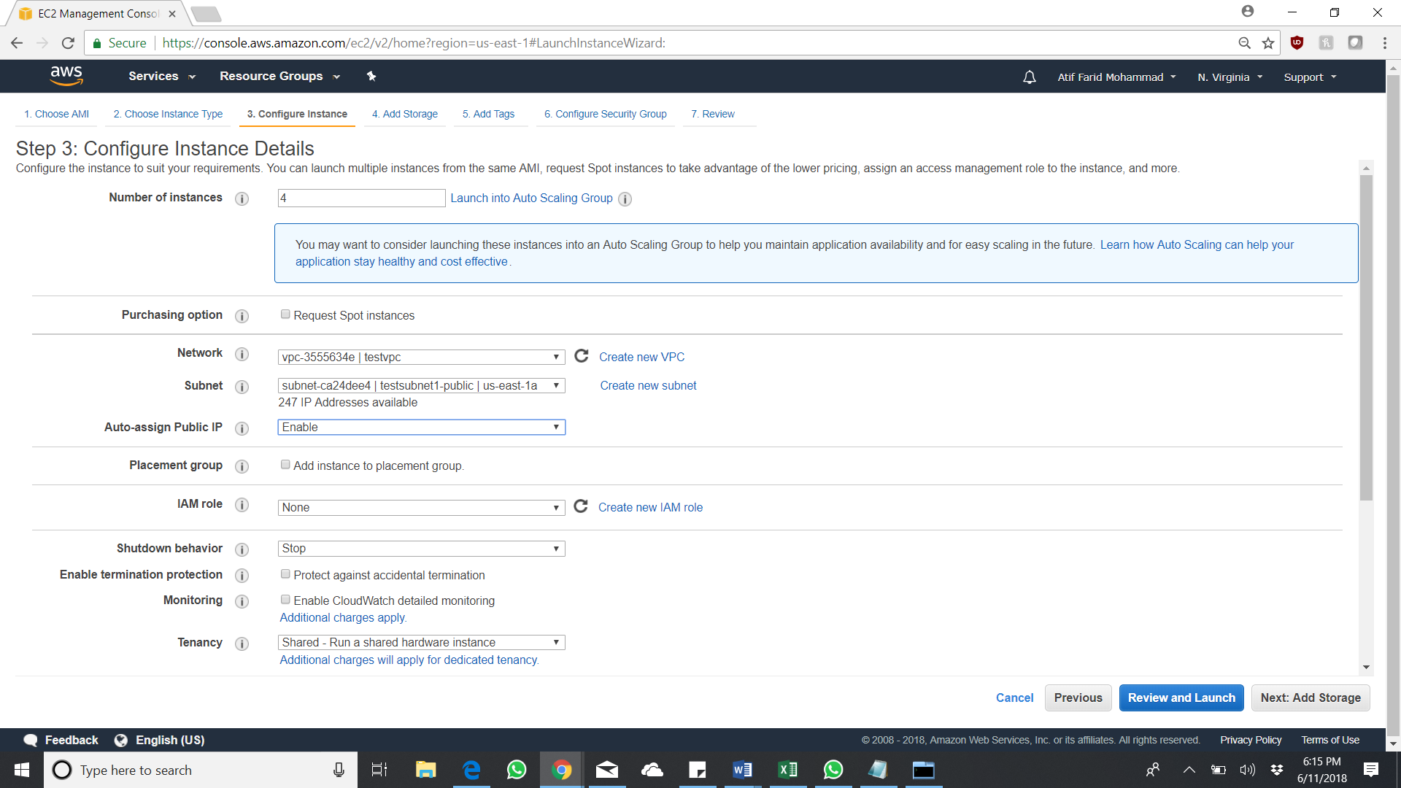

Choose the default one for the storage

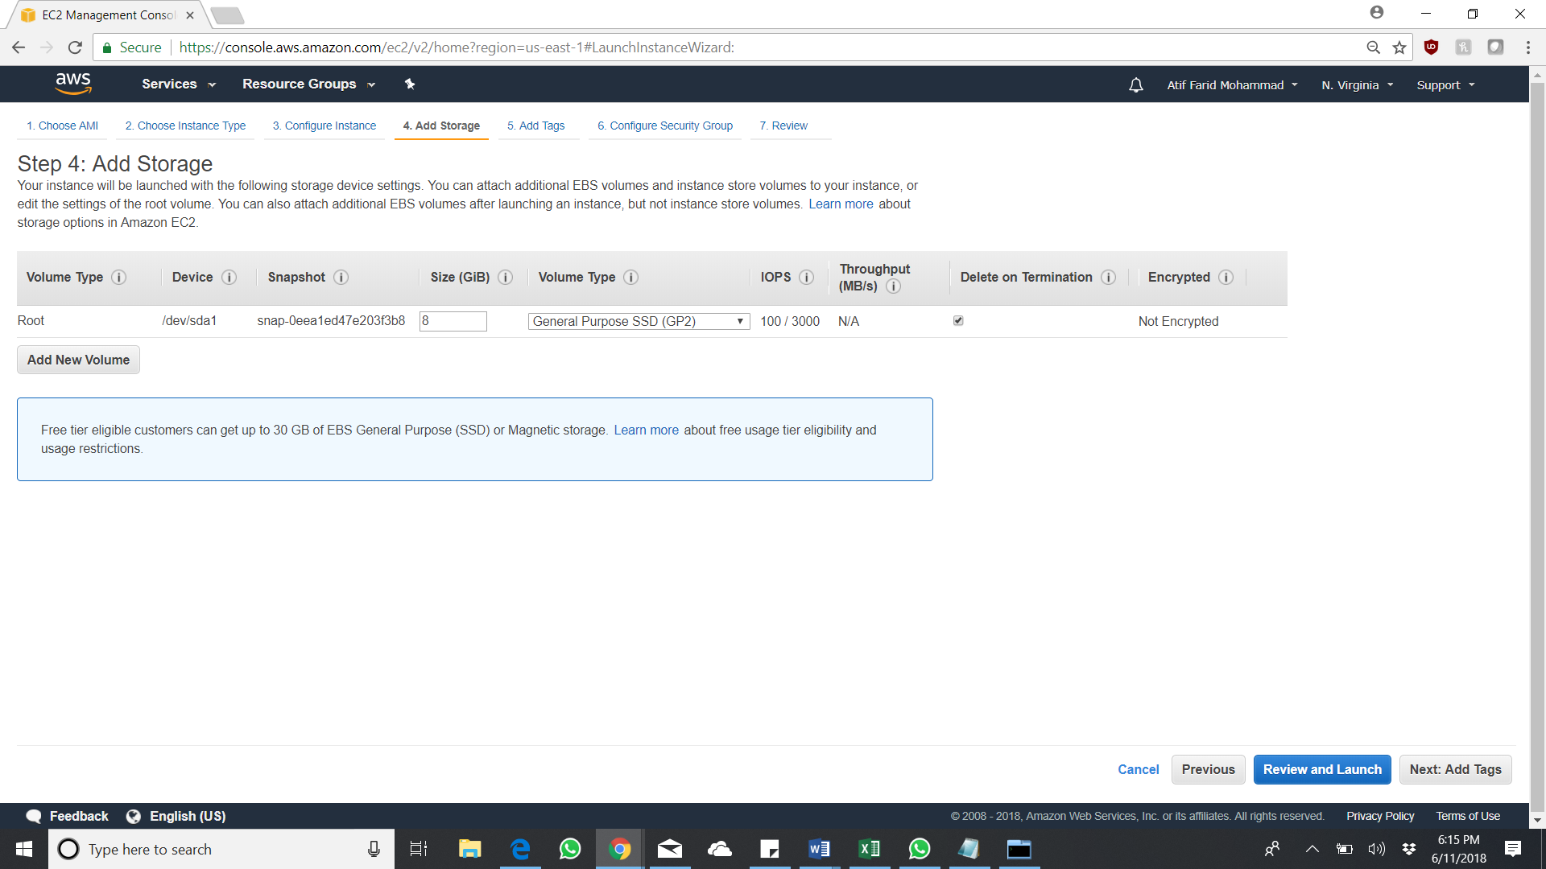

Add tags if required as it would be easy for later purpose

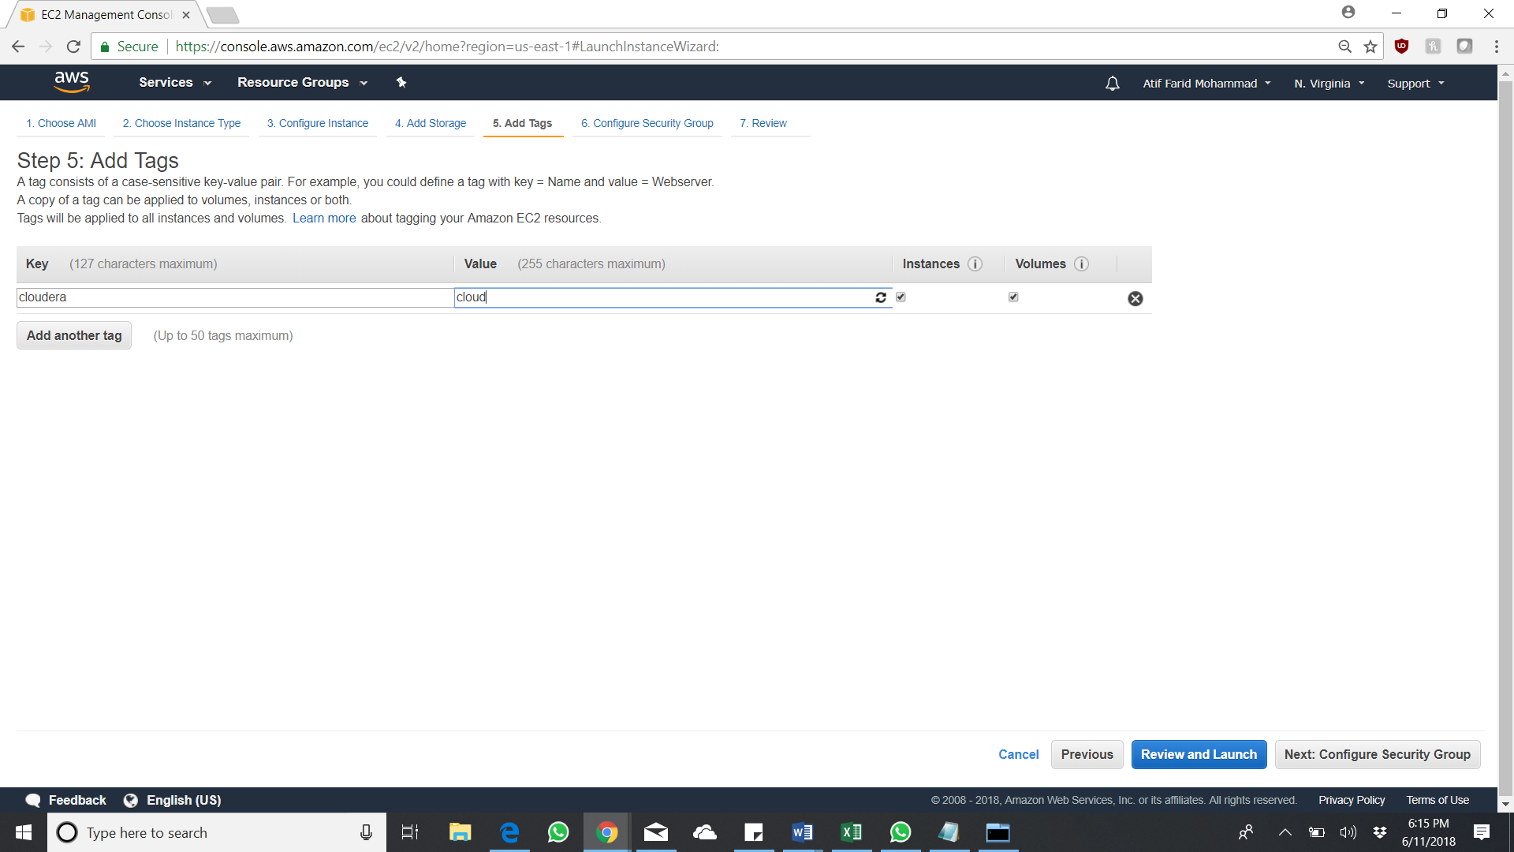

Create a security group with All TCP, All UDP and SSH connectivity

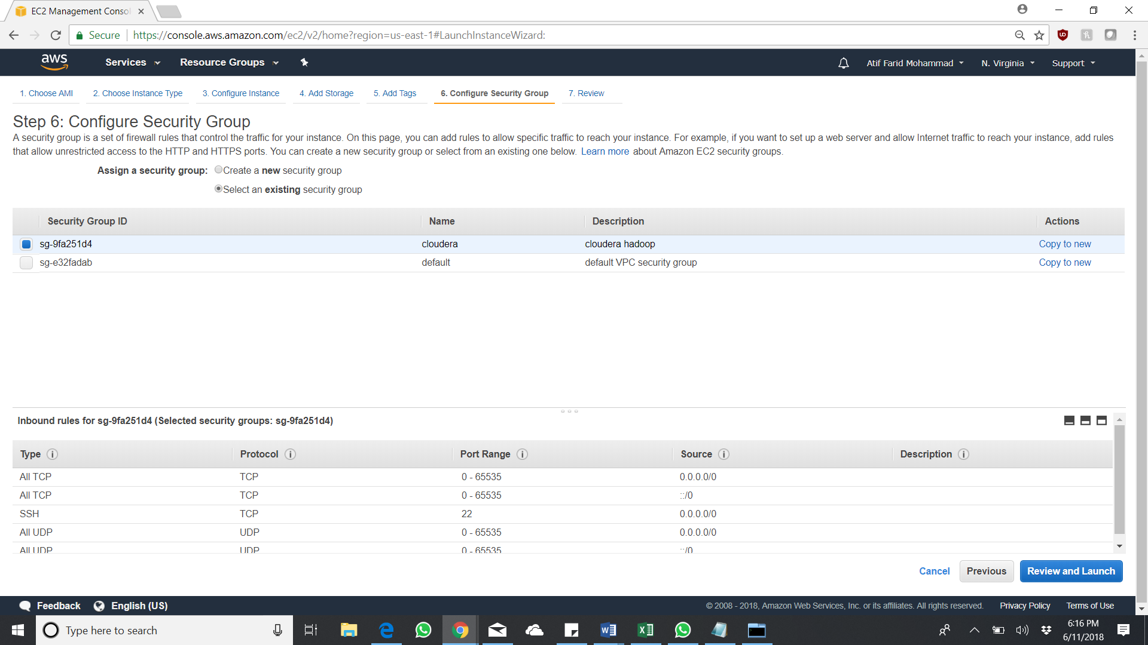

Review and Launch

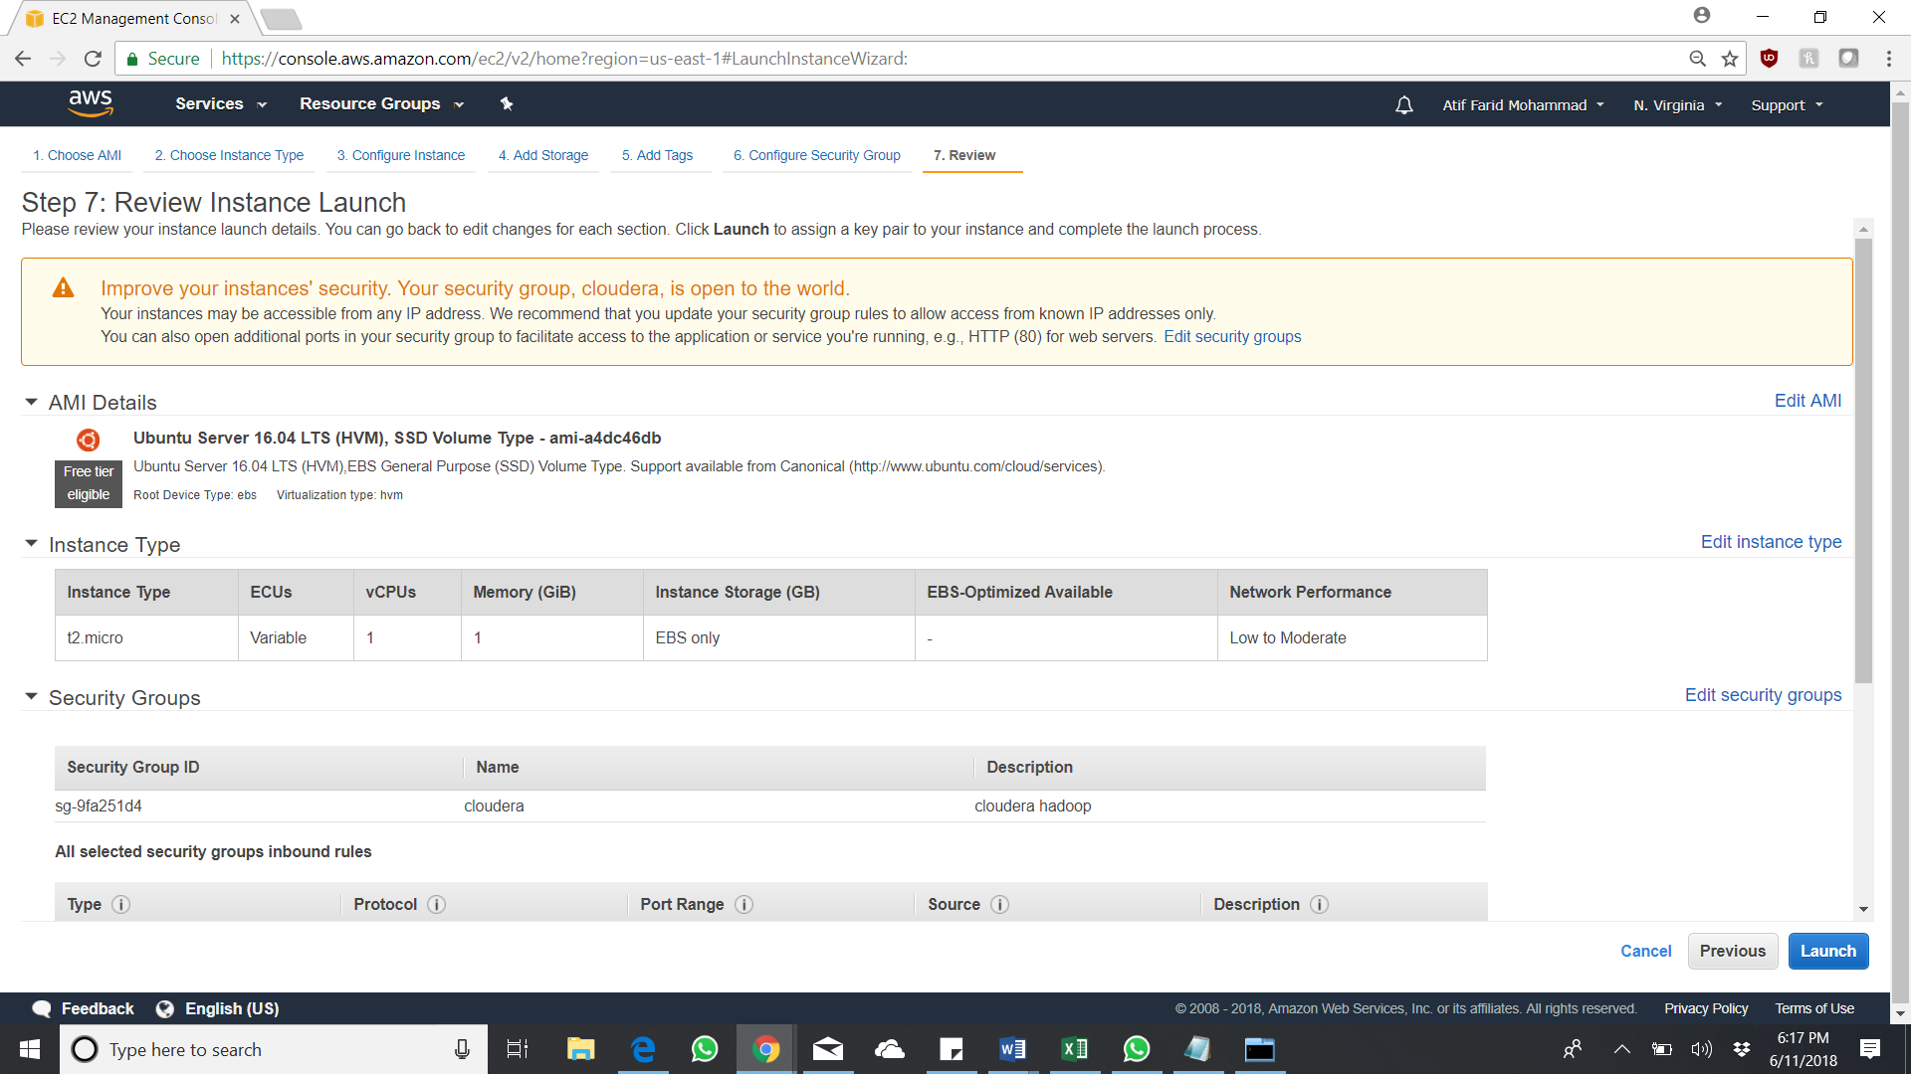

Create or use an existing key pair as it will be used to connect to the instance via SSH using Putty

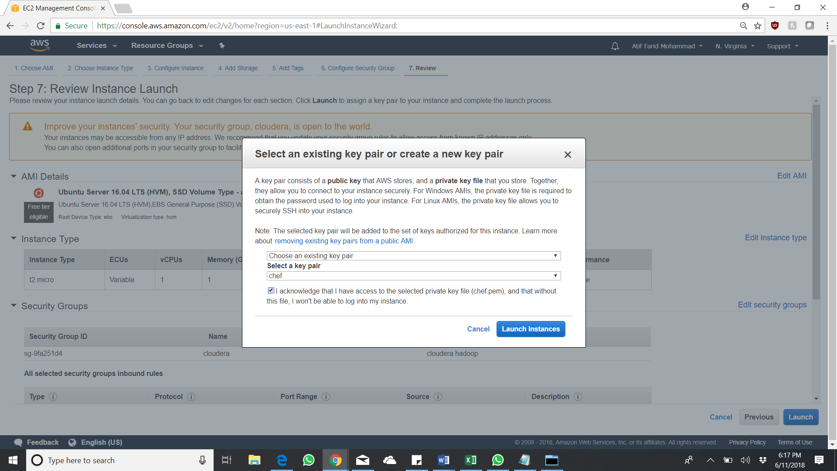

Instances successfully created. Its up and running.

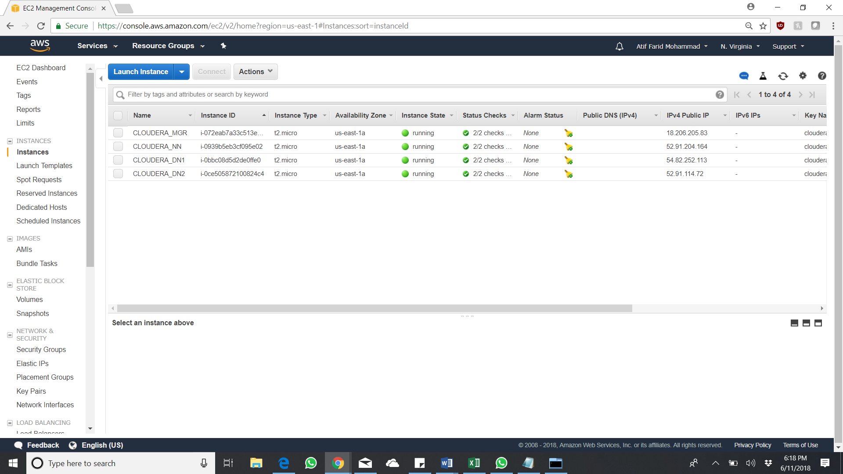

# PRE-STEPS for CLOUDERA INSTALLATION

After the AWS EC2 instances are up and running, we have to convert the putty .pem file to a .ppk file for putty to recognize. Hence use puttygen to convert it into a .ppk file.

Click Save Private key in puttygen to save the file in a location.

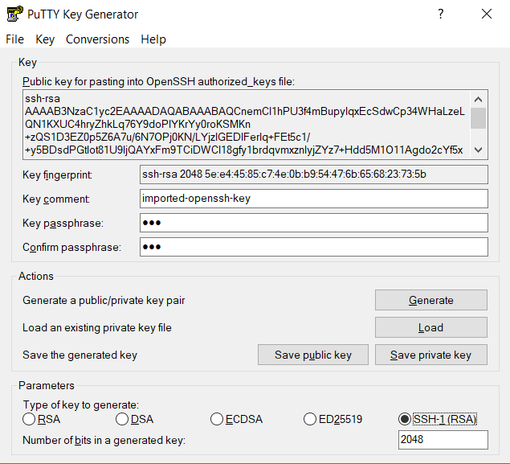

After which open Putty and add the servers accordingly with their public IP’s and the created ppk file as an authentication for SSH connection.

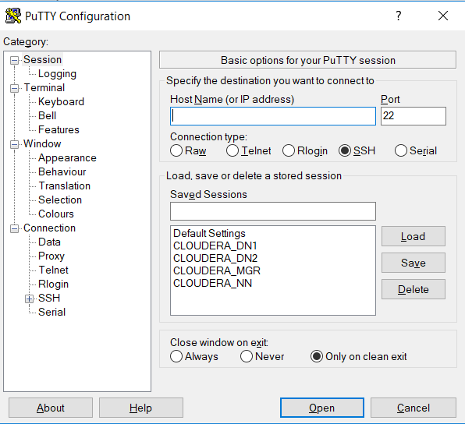

I personally use MTPutty as it would be easy to navigate to multiple servers. And login with the username – ubuntu and the password which you have defined earlier as key phrase when you generate the ppk file from PuttyGen.

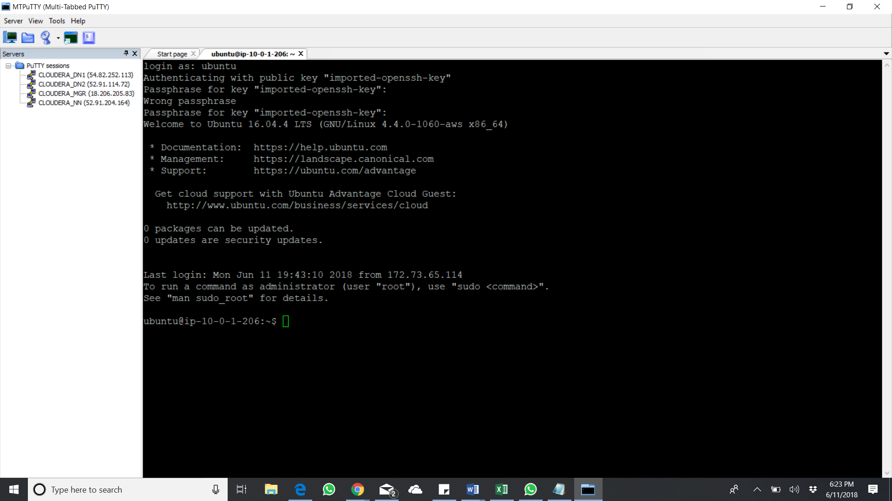

# INSTALLATION of CLOUDERA 5.X on EC2 USING CLOUDERA MANAGER

After successful creation of the AWS EC2 instance, we now start installing the Cloudera 5.X on those instances using Cloudera Manager.

Use the following command on the CLOUDERA_MGR instance specified,

* yum install wget

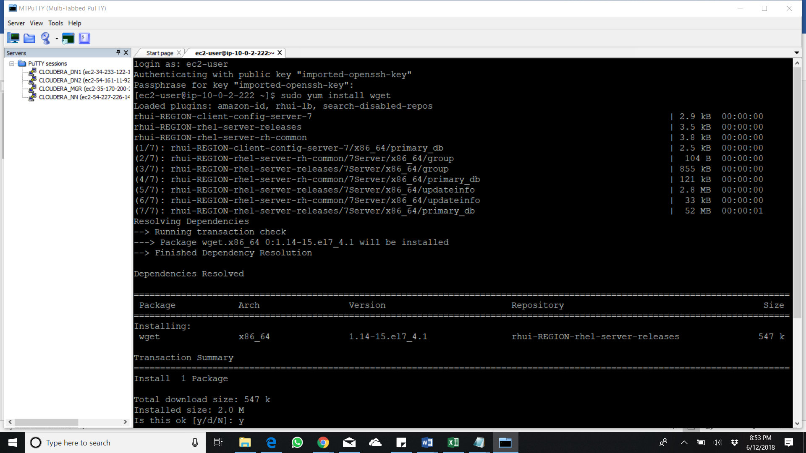

* sudo su
* vi /etc/selinux/config

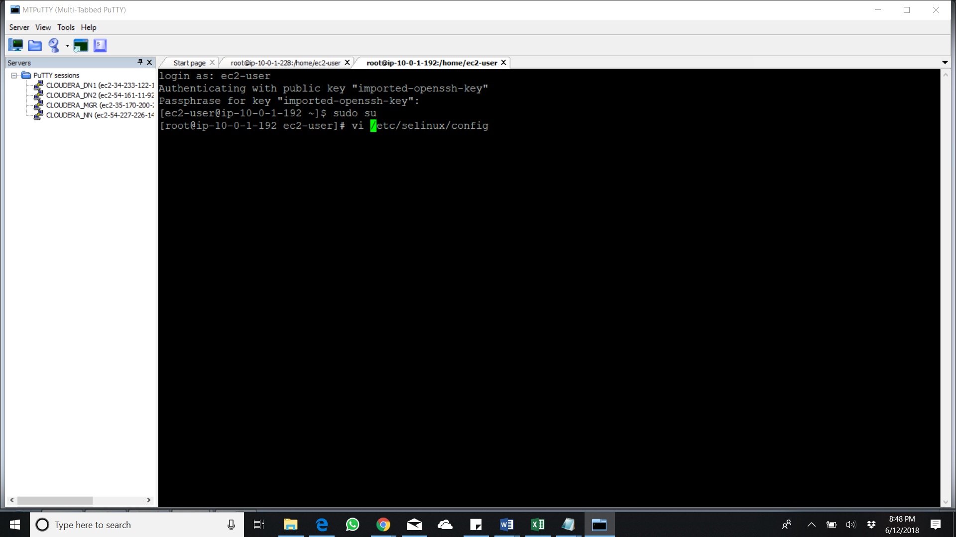

Change the SELINUX = enforcing to SELINUX = disabled in all the nodes

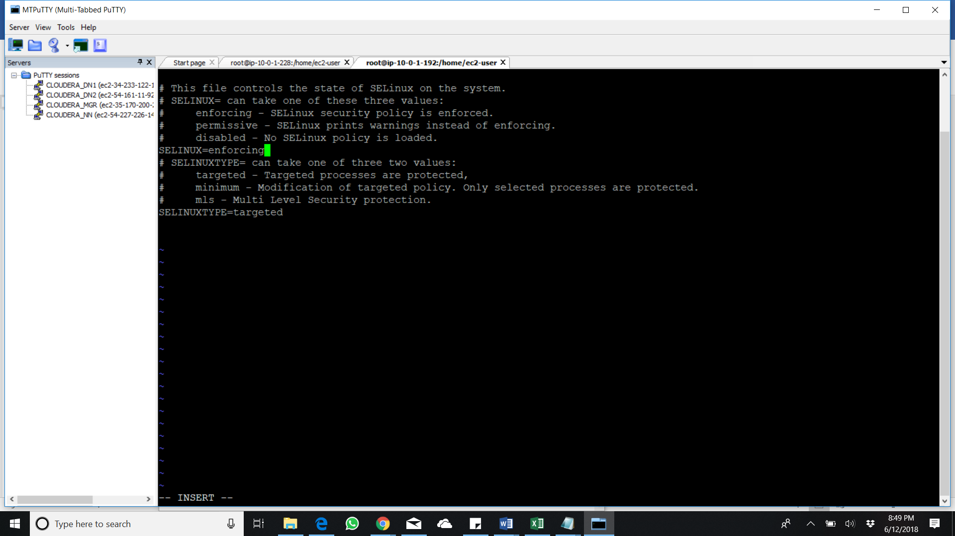

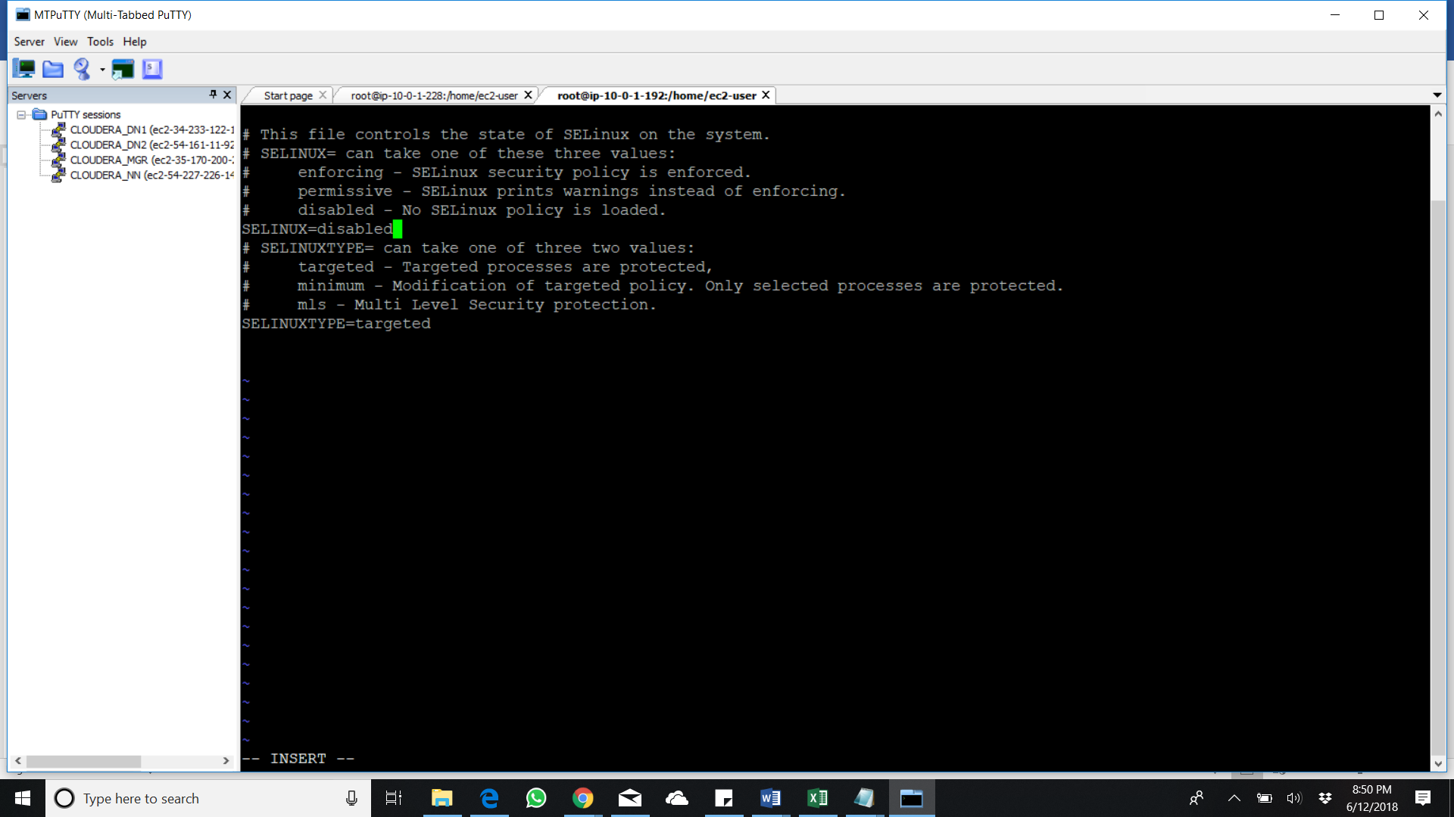

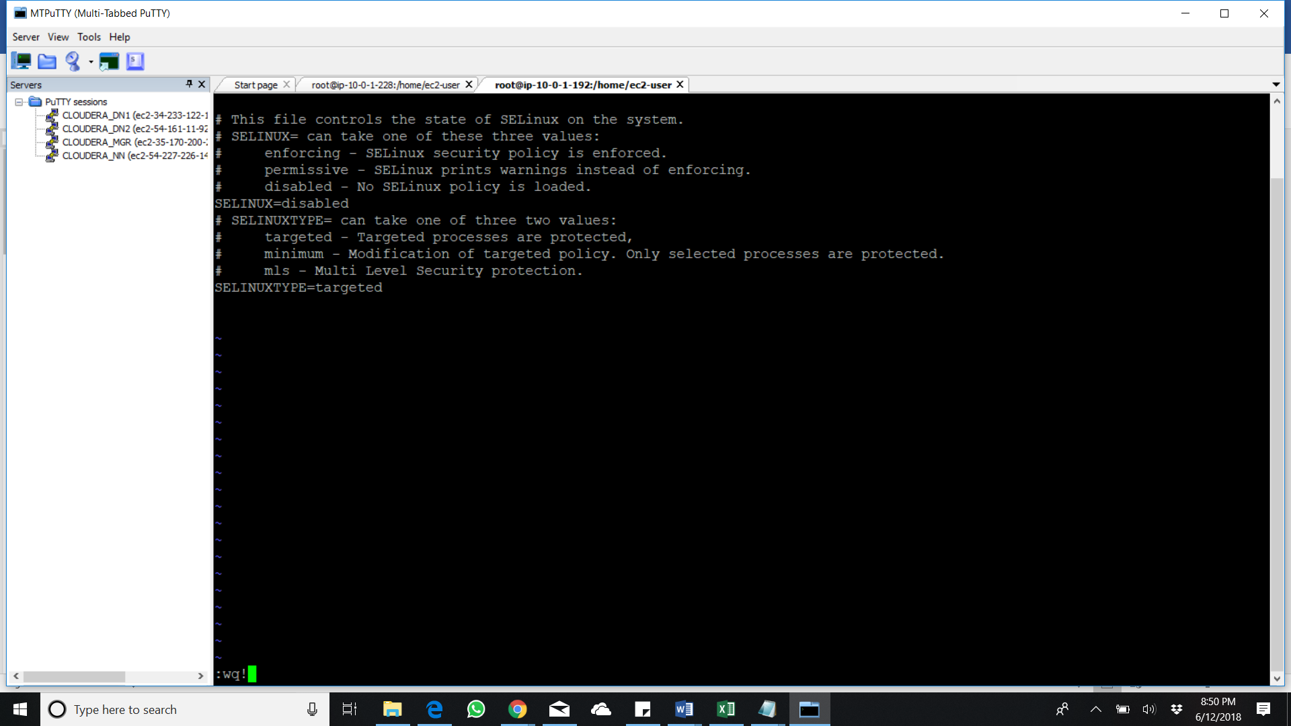

Reboot the server after that to make the changes applied

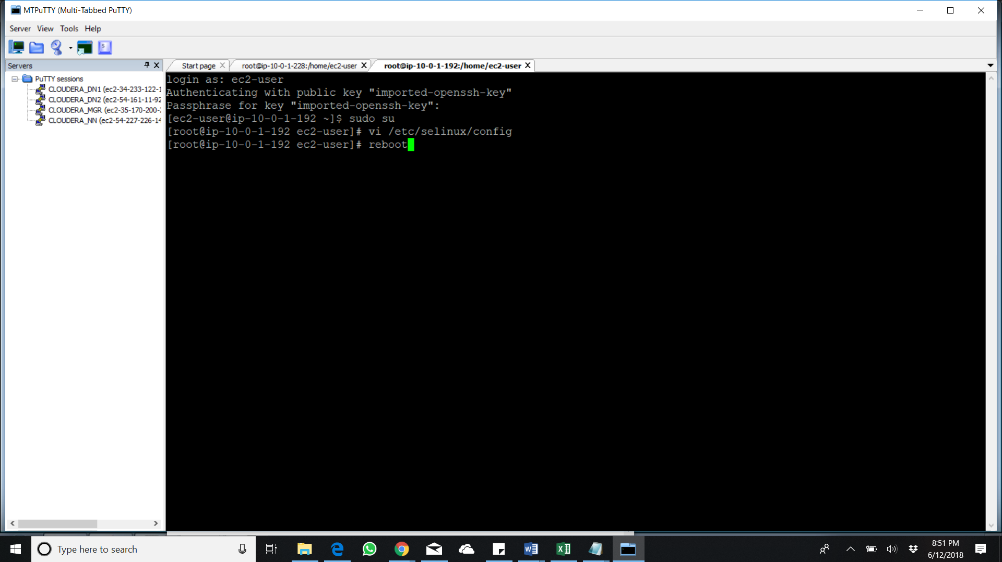

wget <http://archive.cloudera.com/cm5/installer/latest/cloudera-manager-installer.bin>

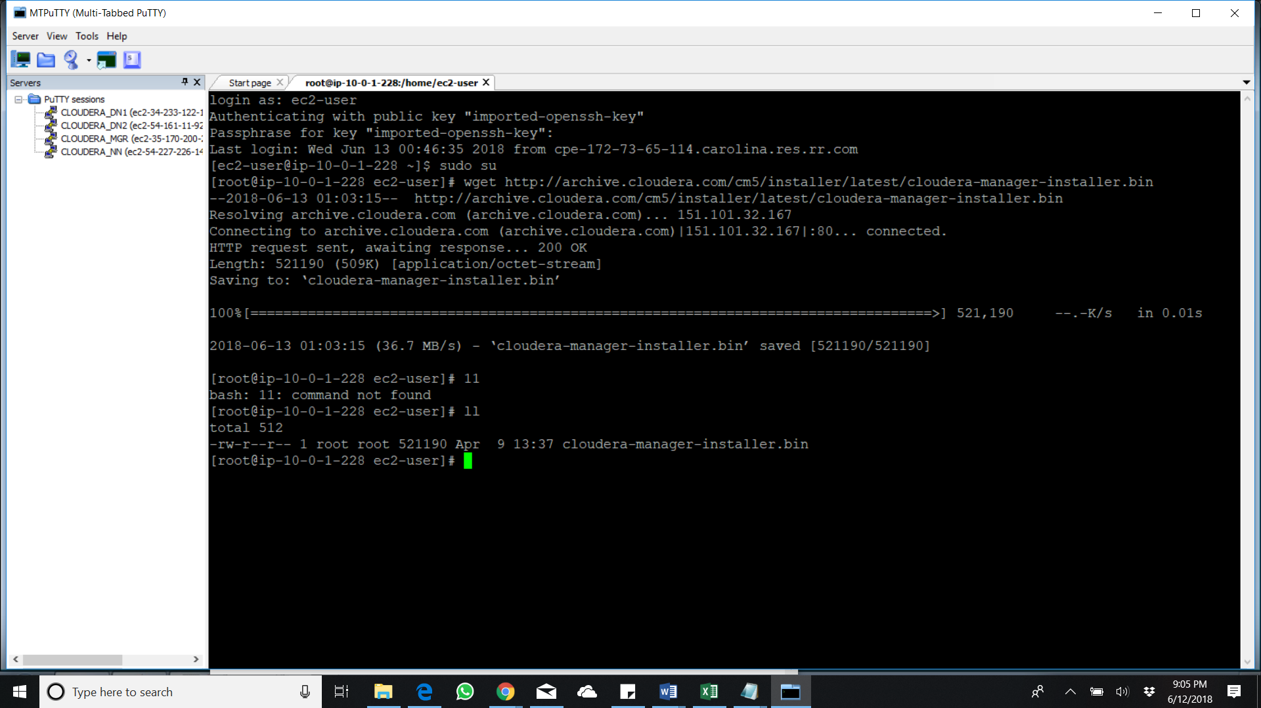

chmod 777 cloudera-manager-installer.bin

./cloudera-manager-installer.bin

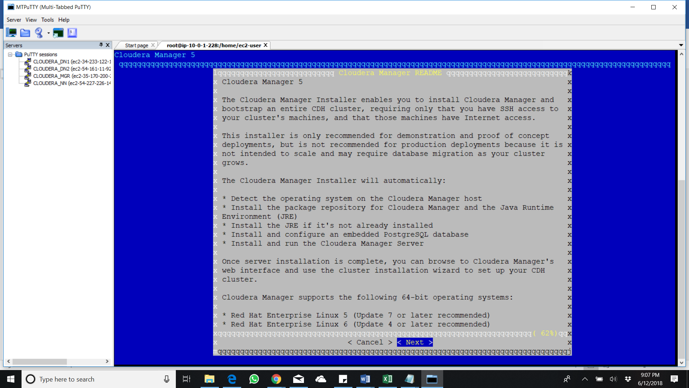

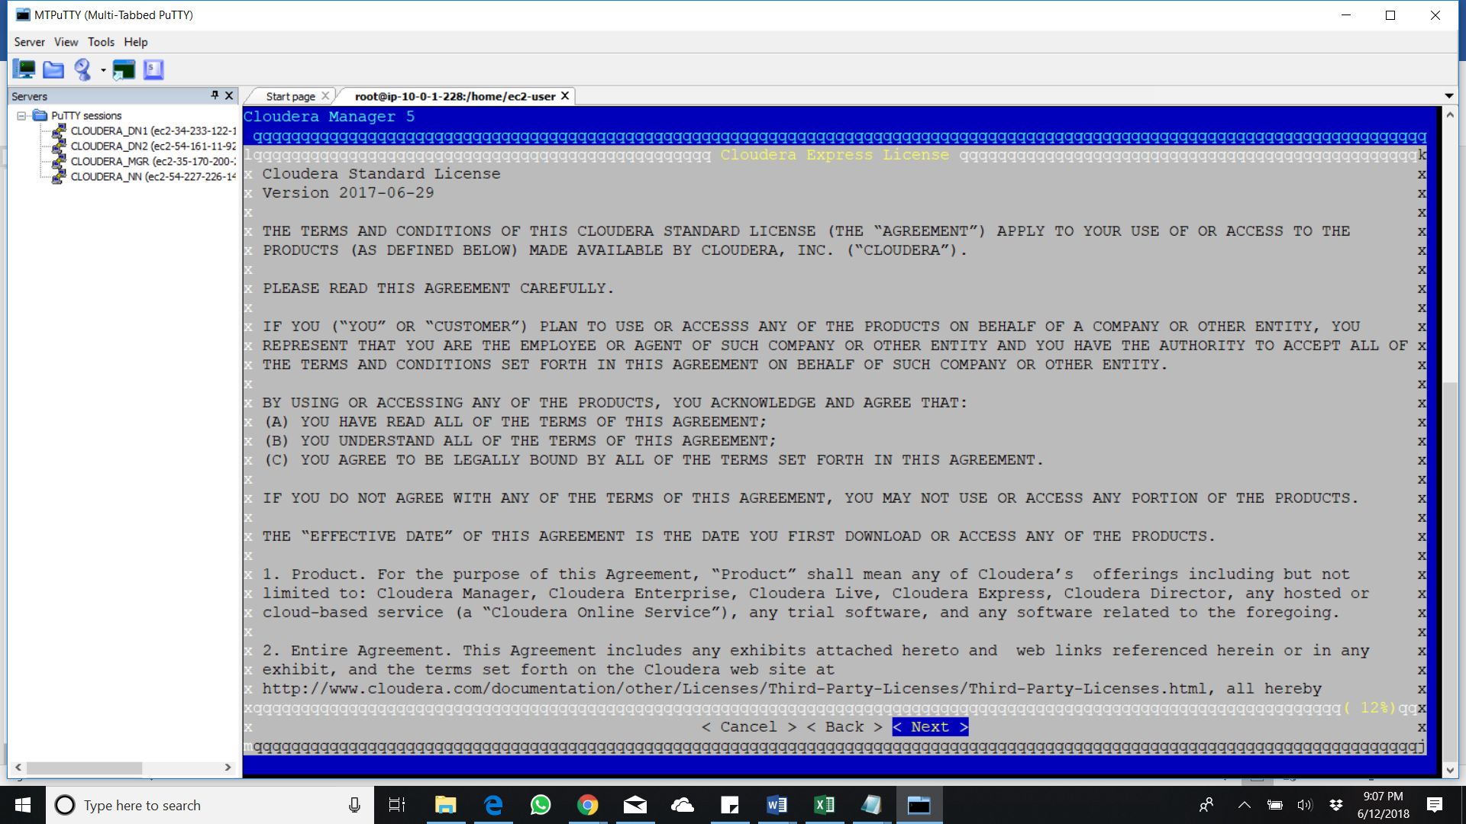

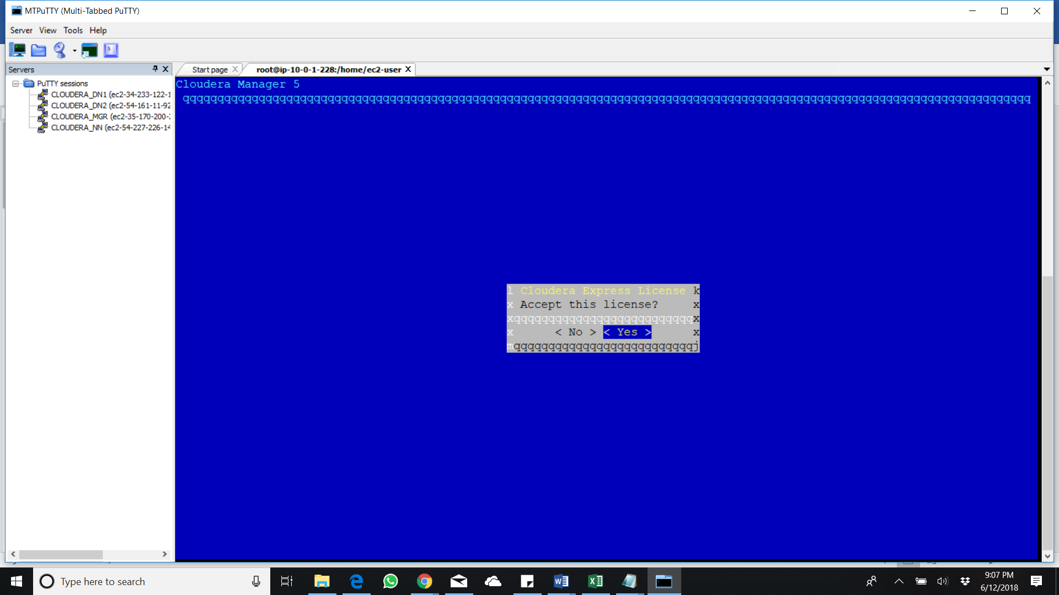

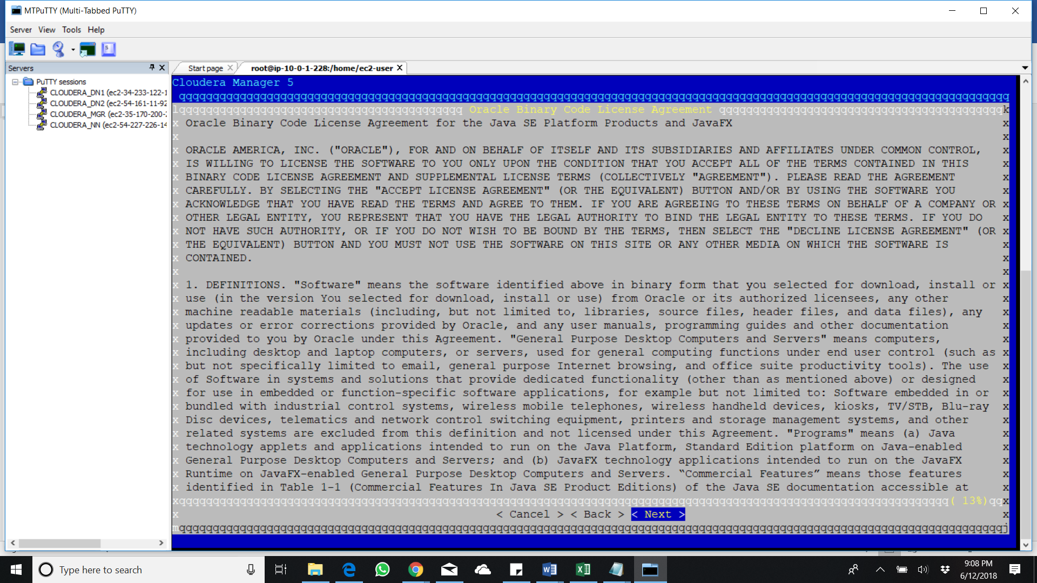

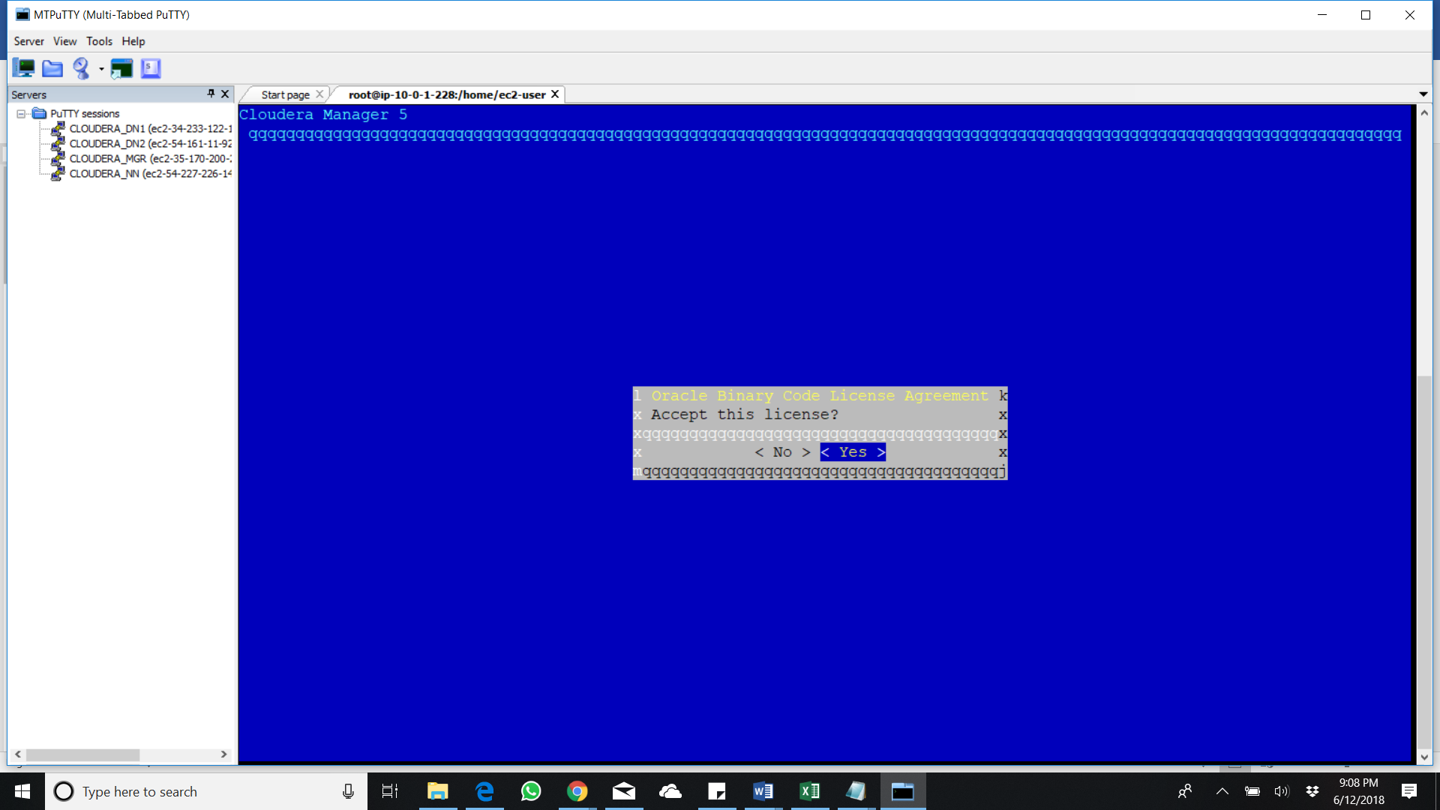

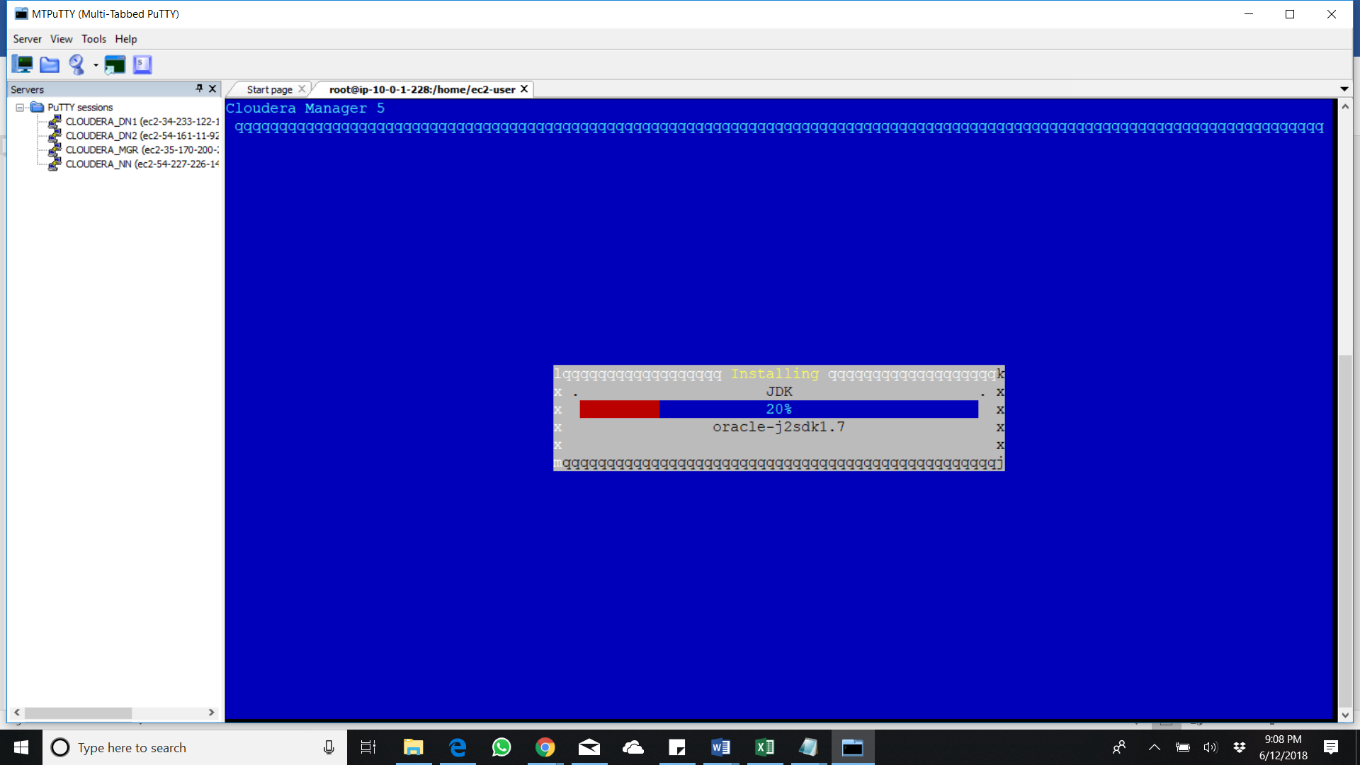

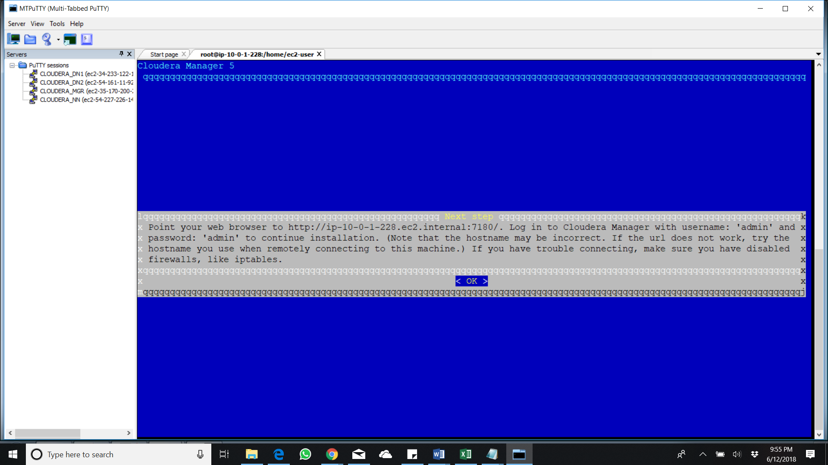

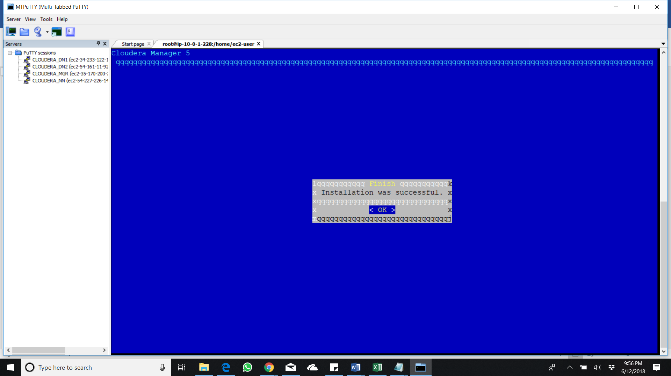

https://www.sudoadmin.com/install-enable-epel-repo-linux-centosrhelscientific-linux/

<https://www.cyberciti.biz/faq/find-linux-distribution-name-version-number/>

<http://www.cloudera.com/documentation/manager/5-0-x/Cloudera-Manager-Quick-Start/Cloudera-Manager-Quick-Start-Guide.html>

https://tecadmin.net/install-python-2-7-on-centos-rhel/

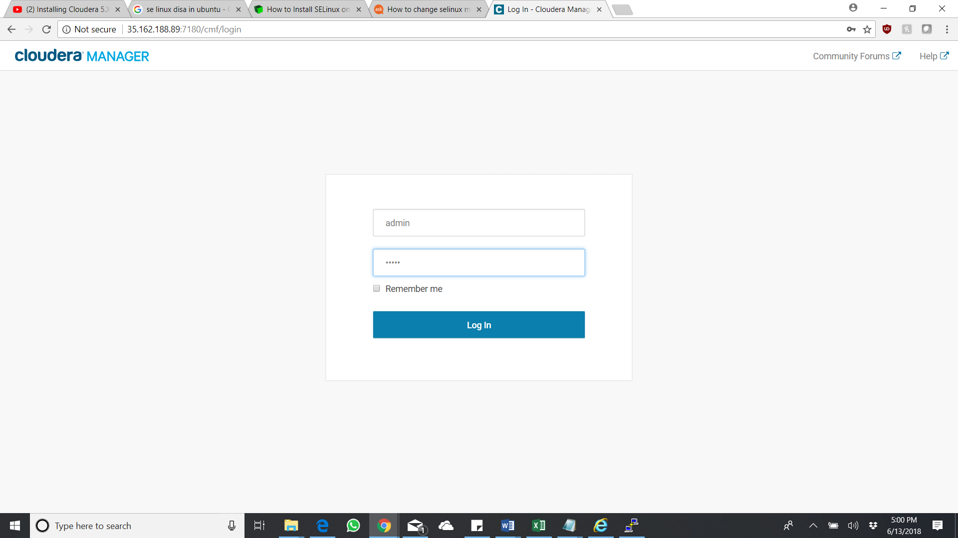

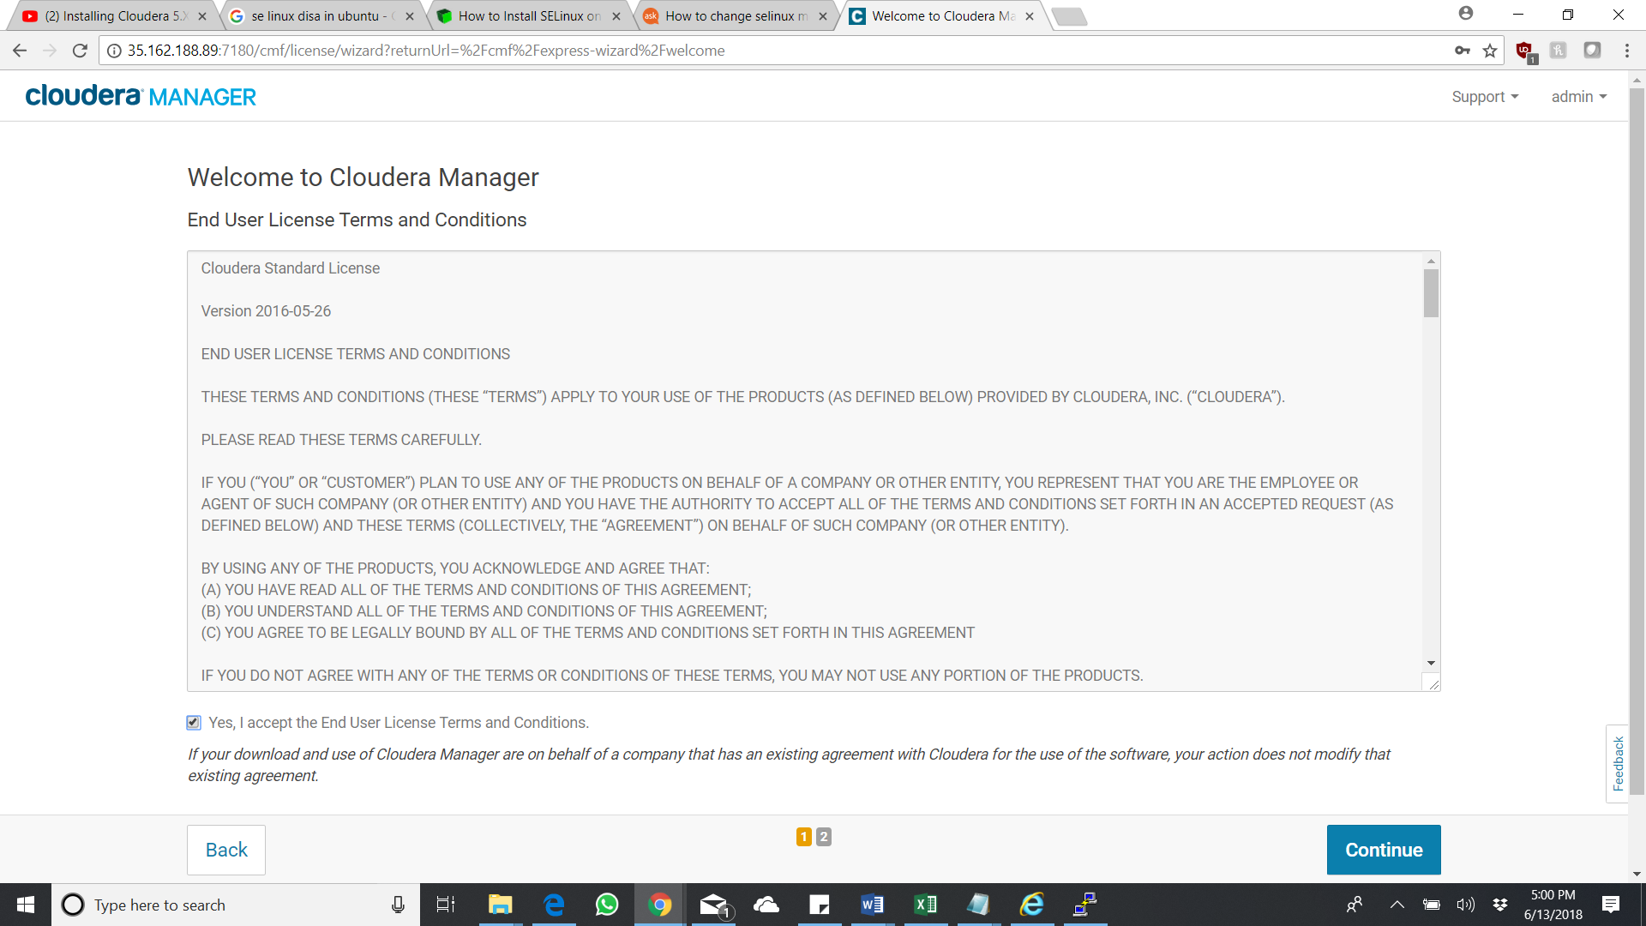

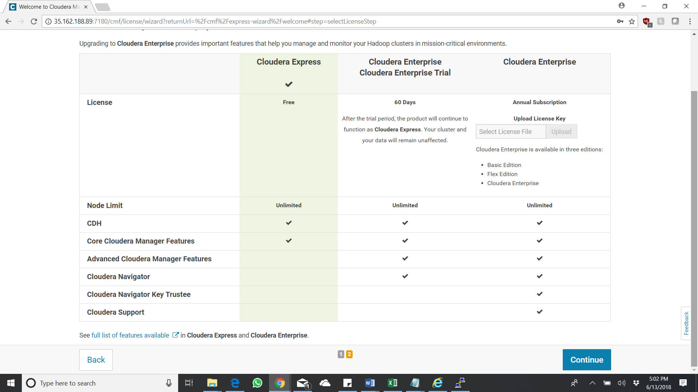

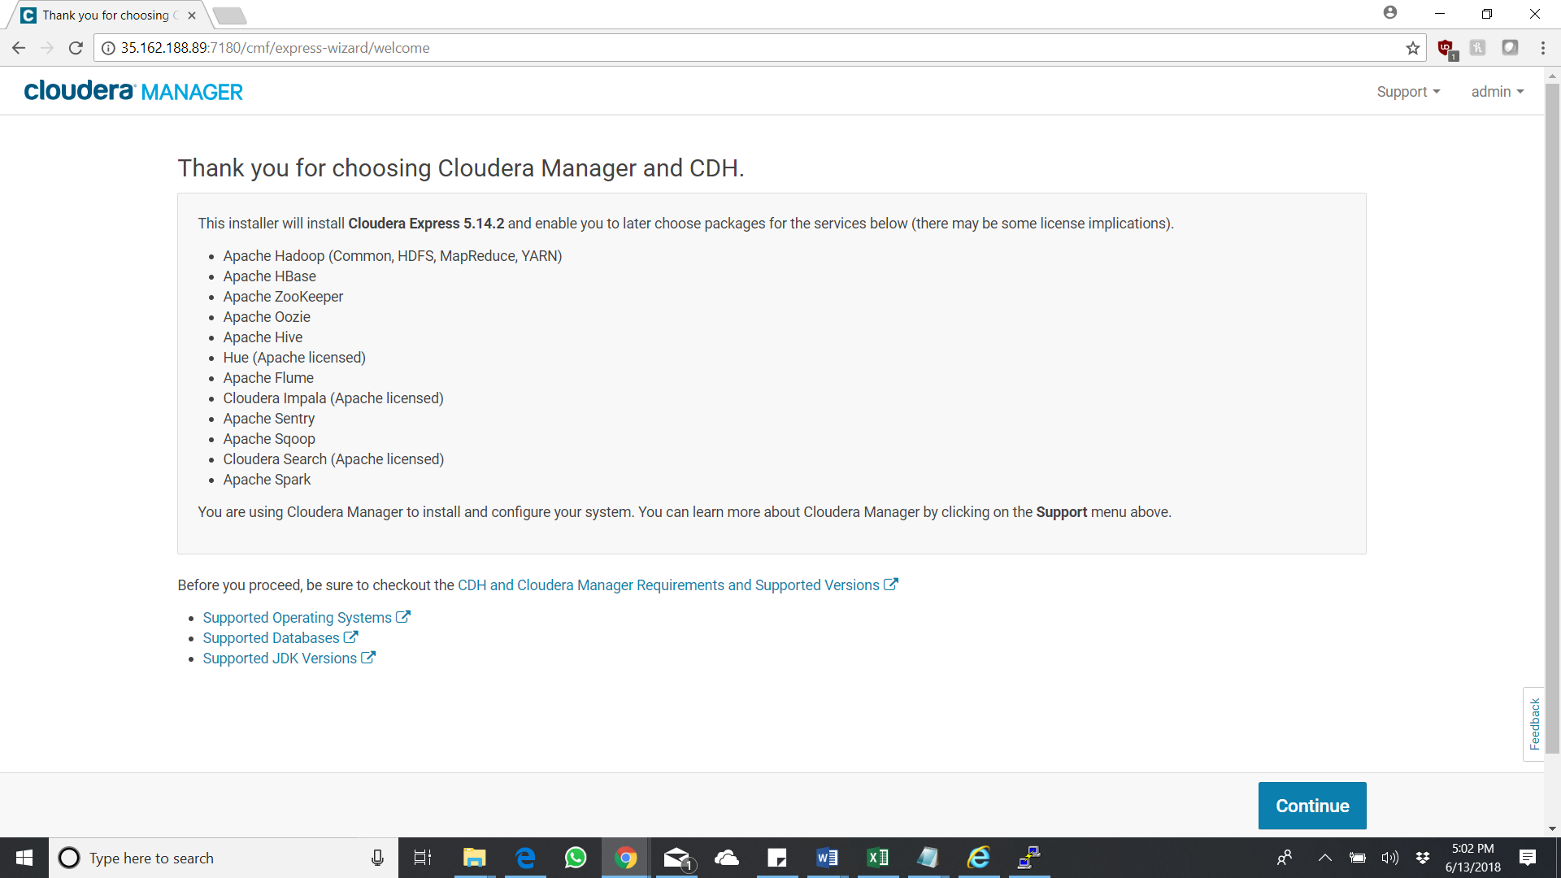

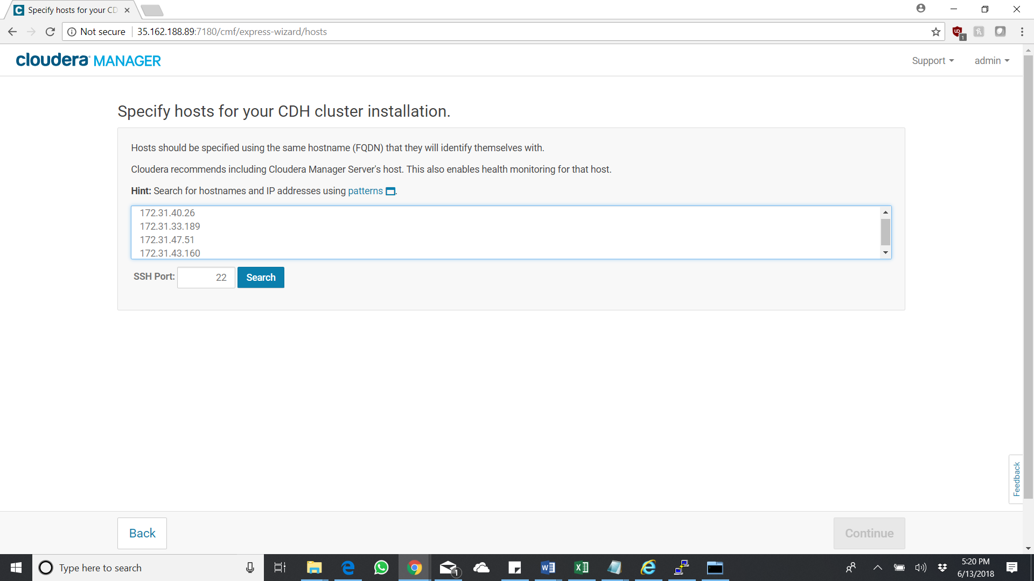

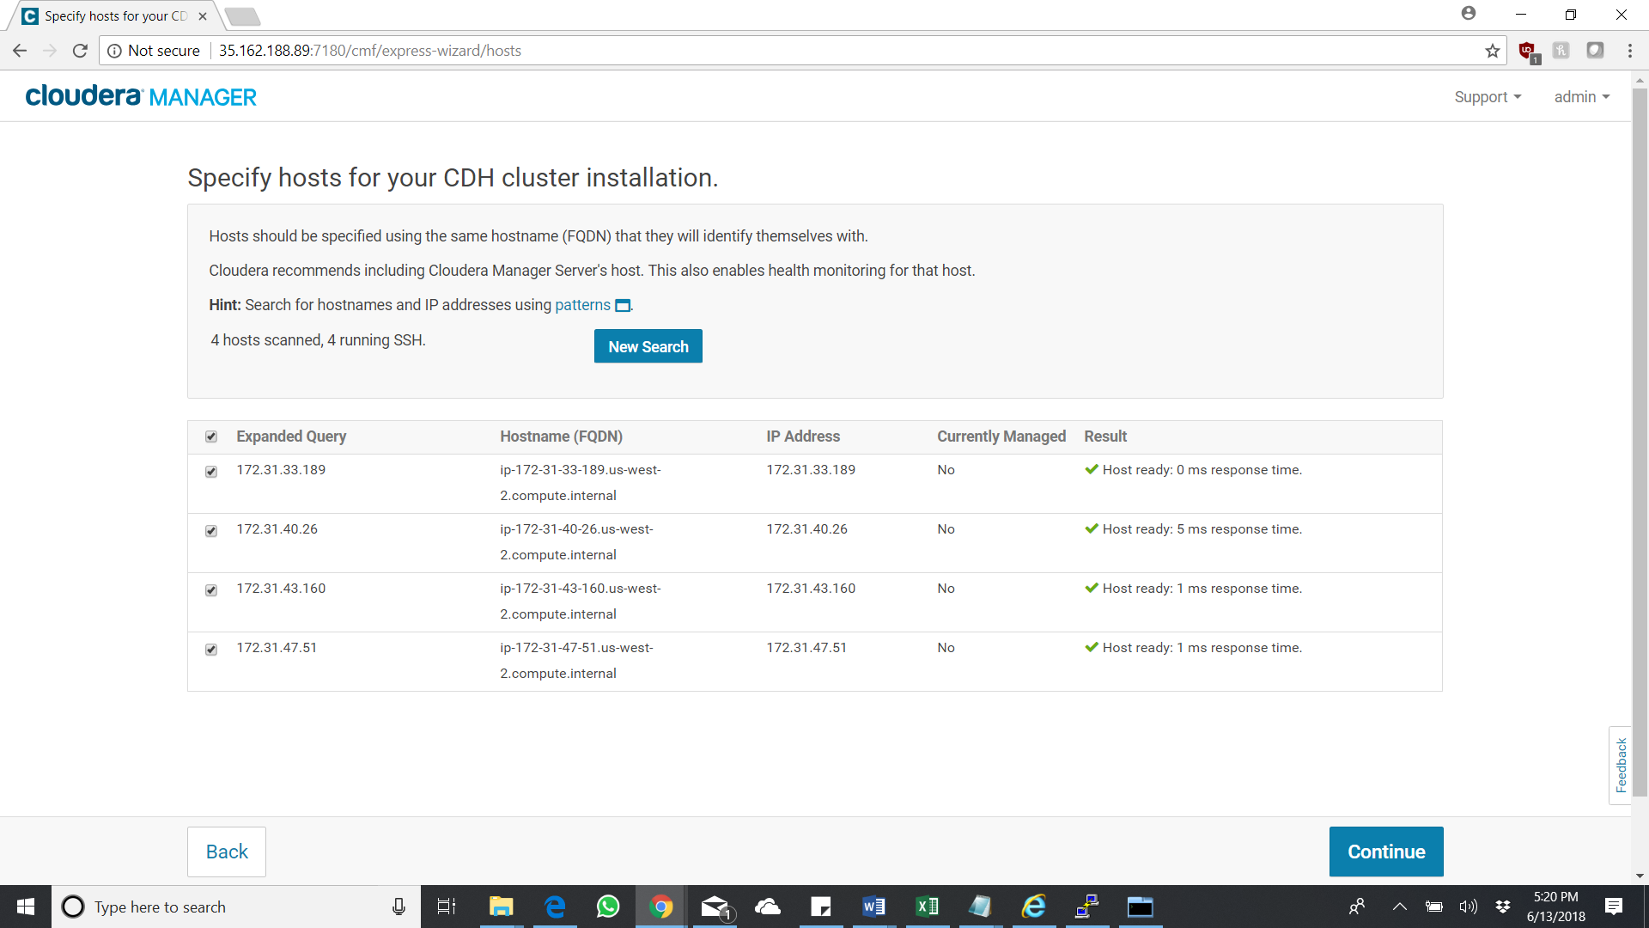

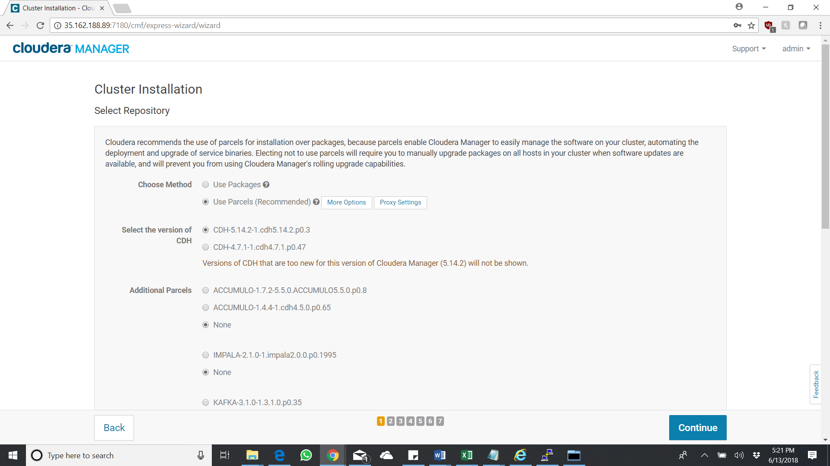

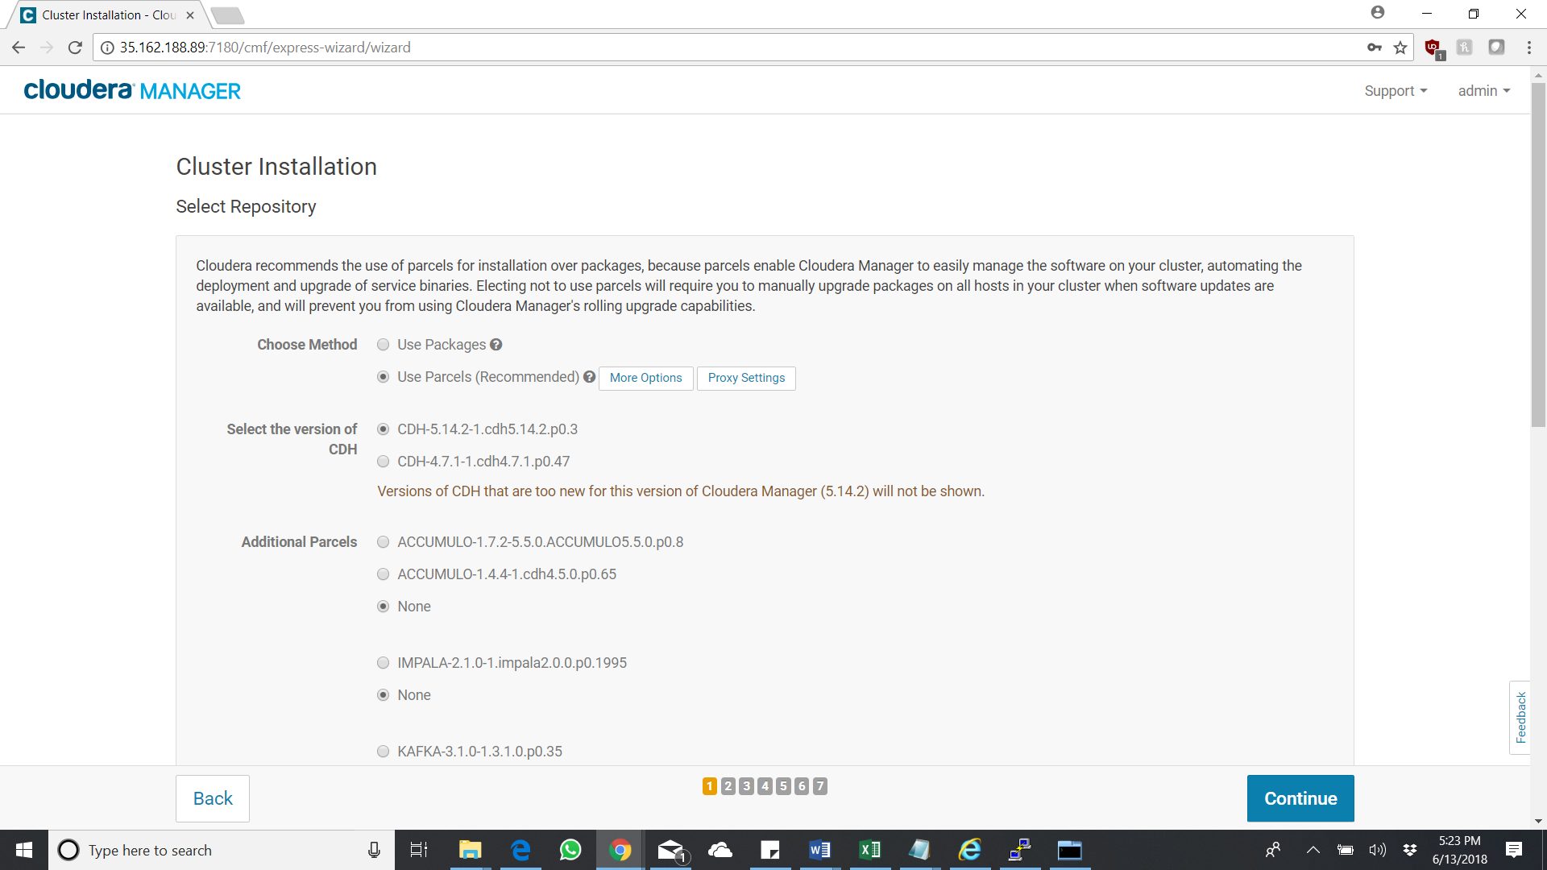

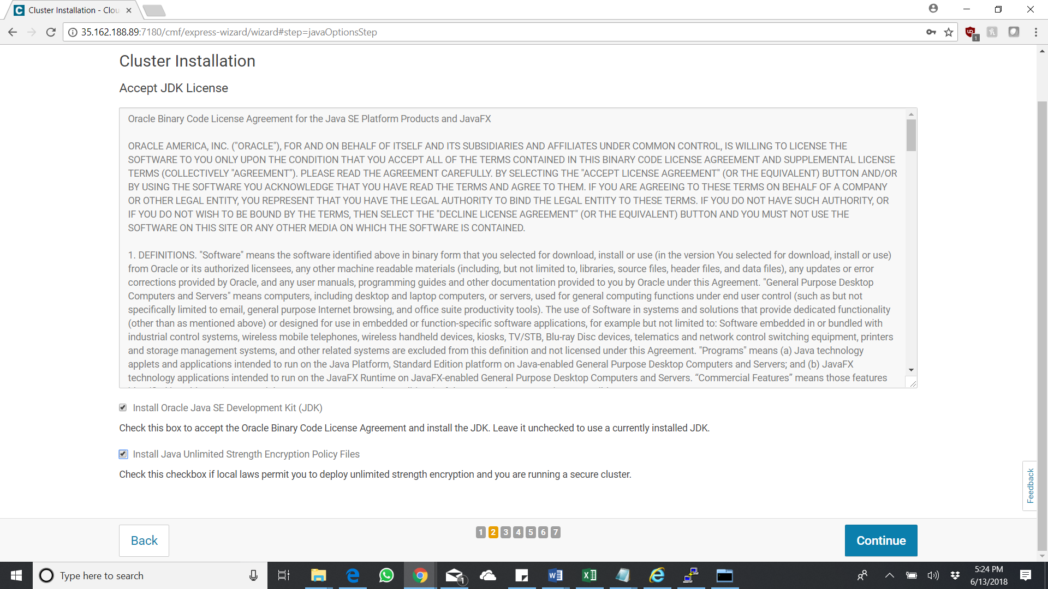

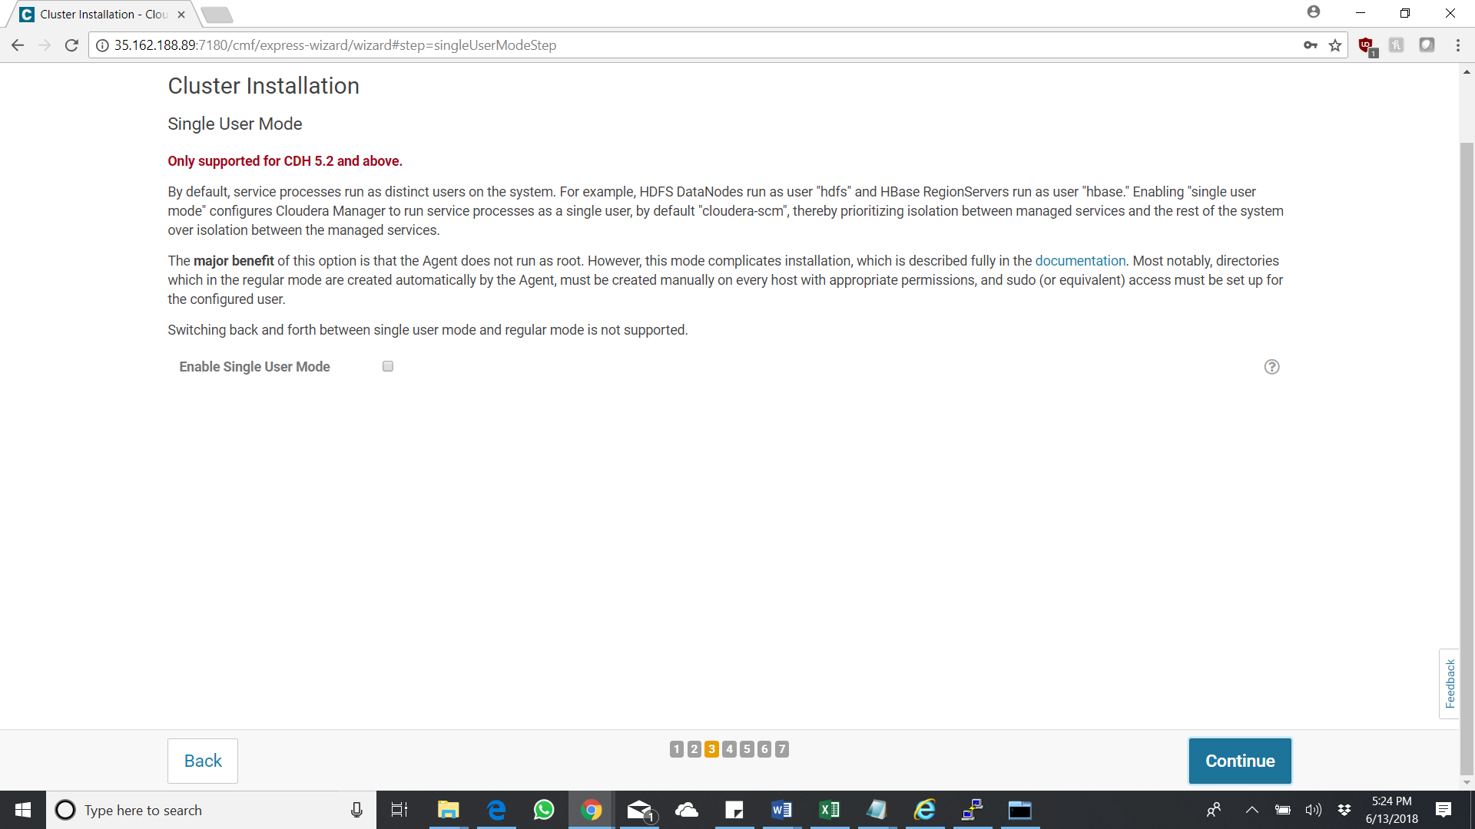

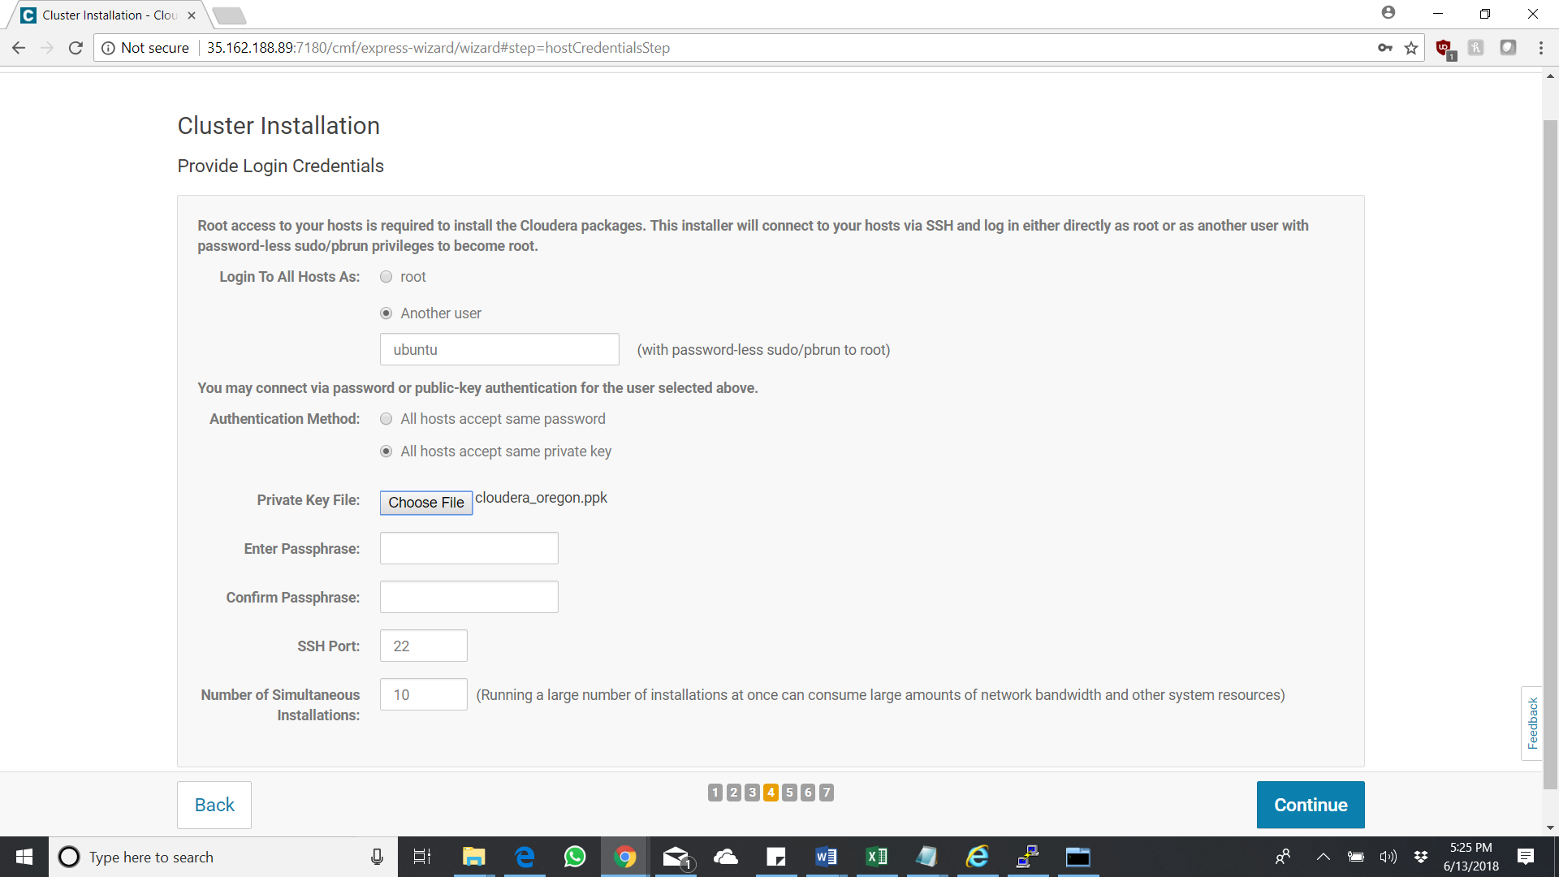

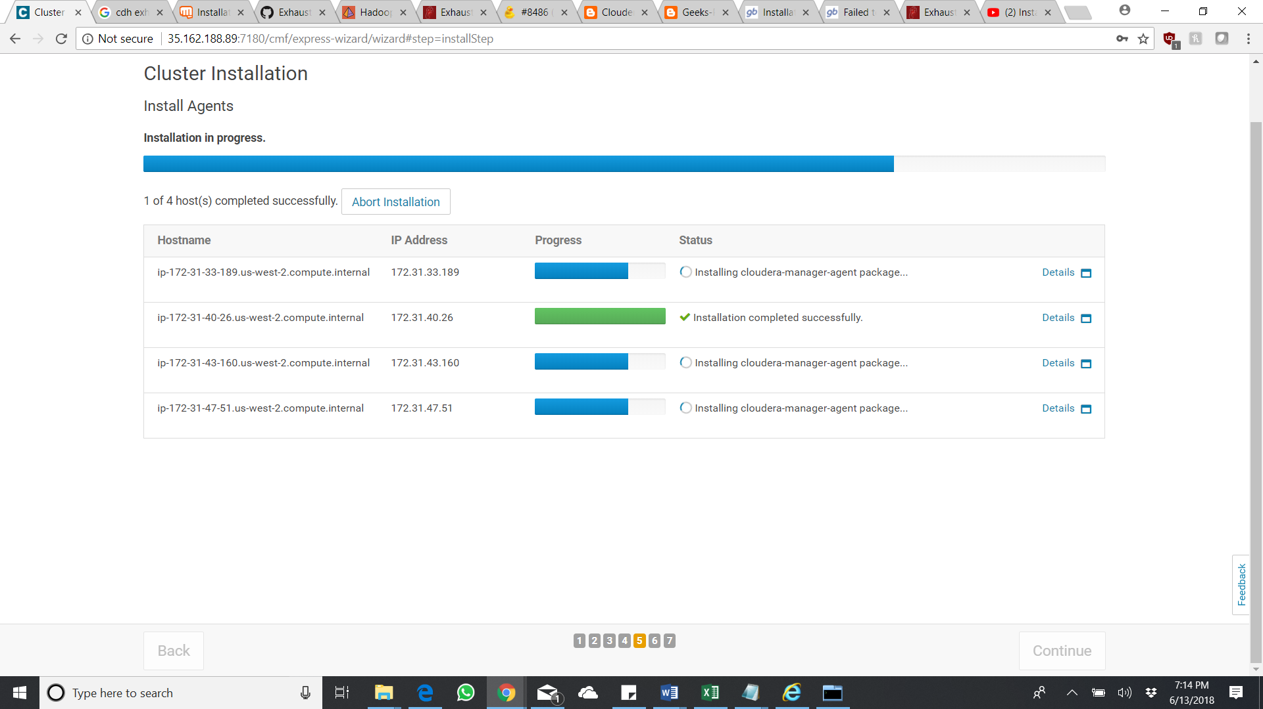

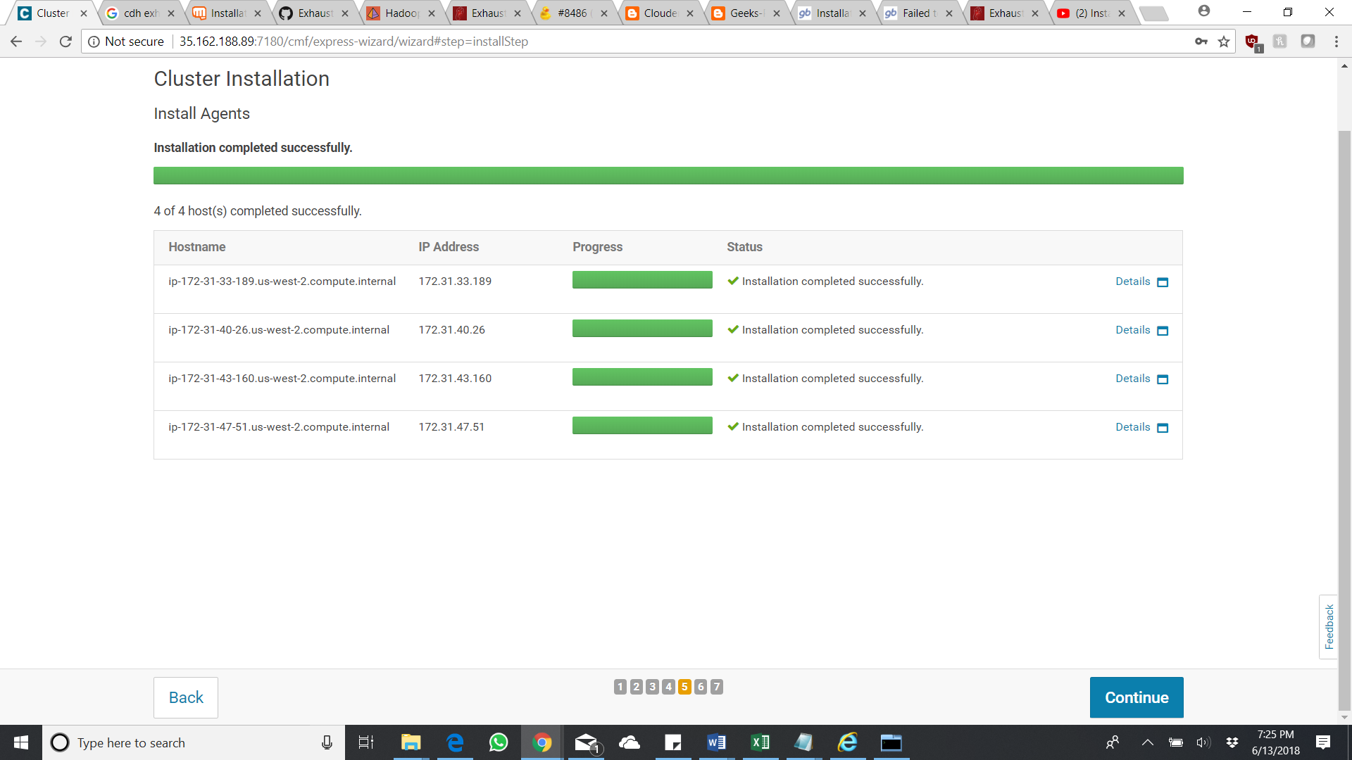

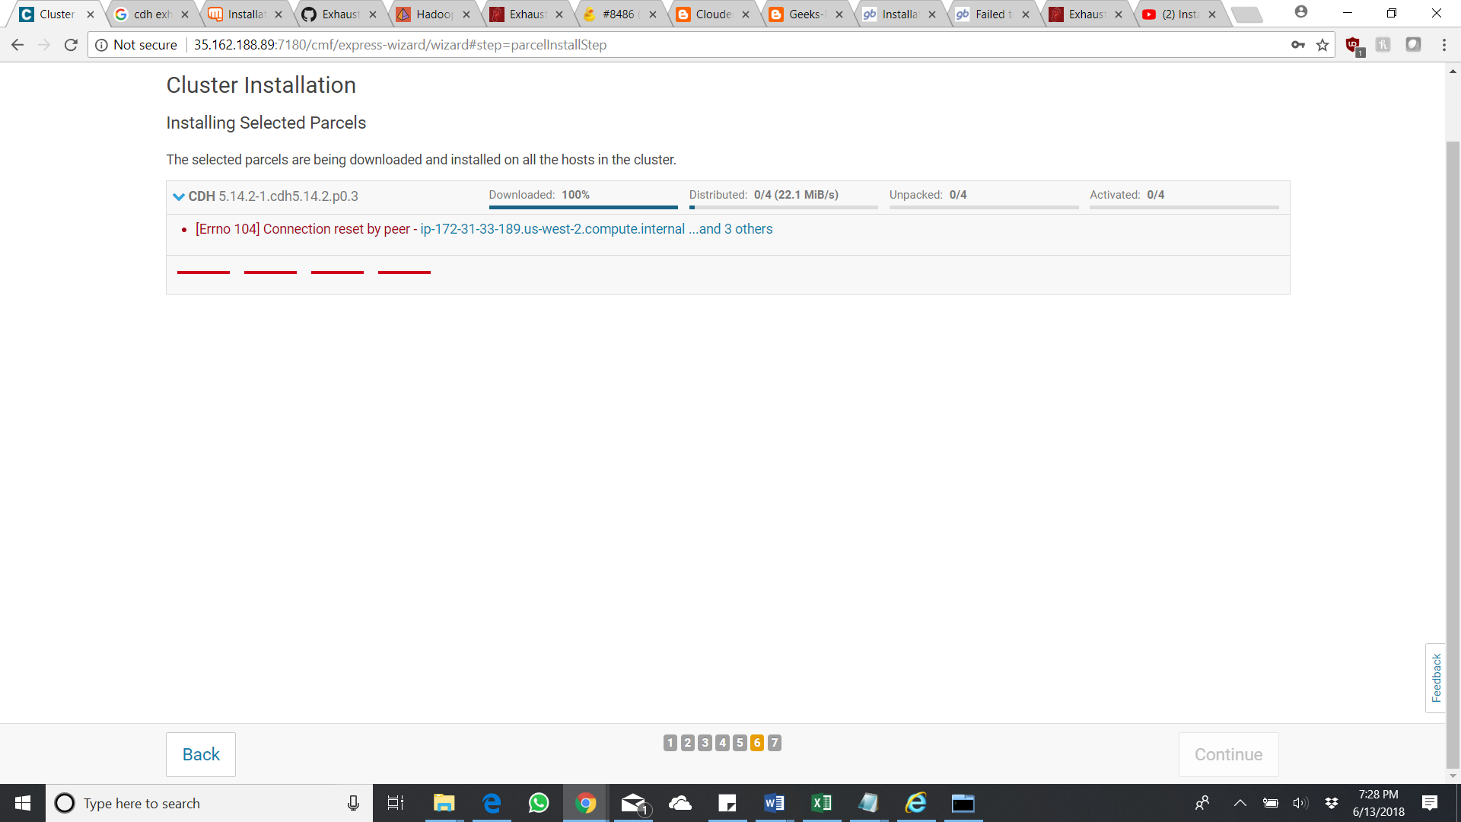

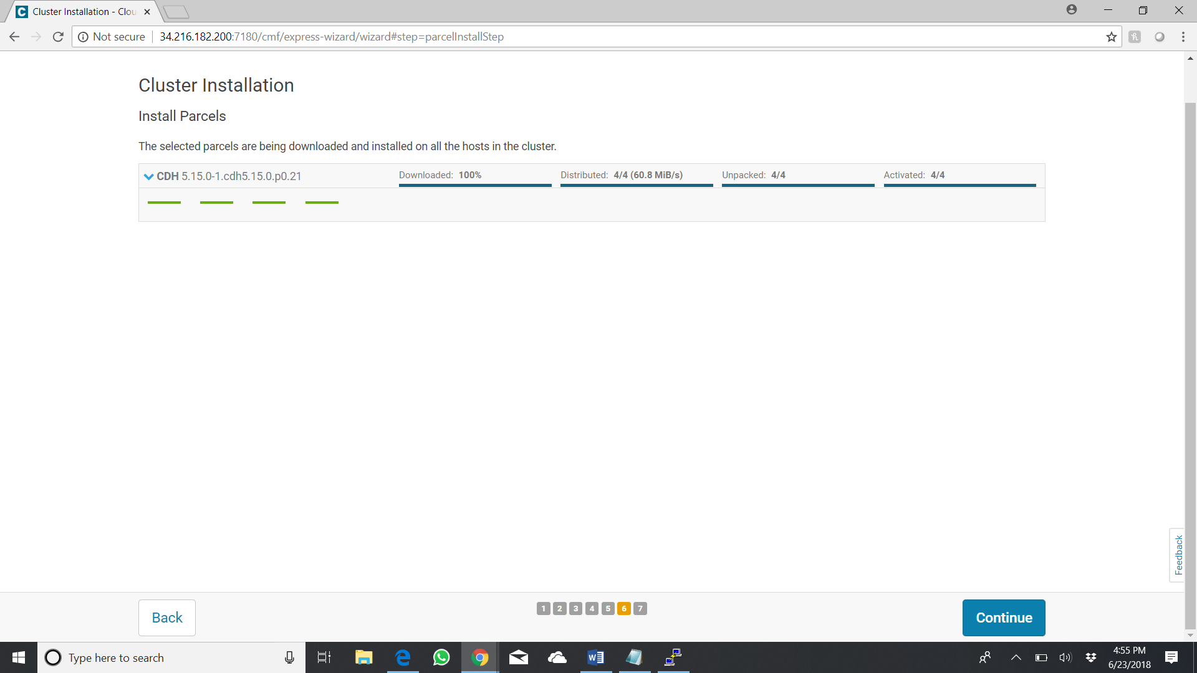

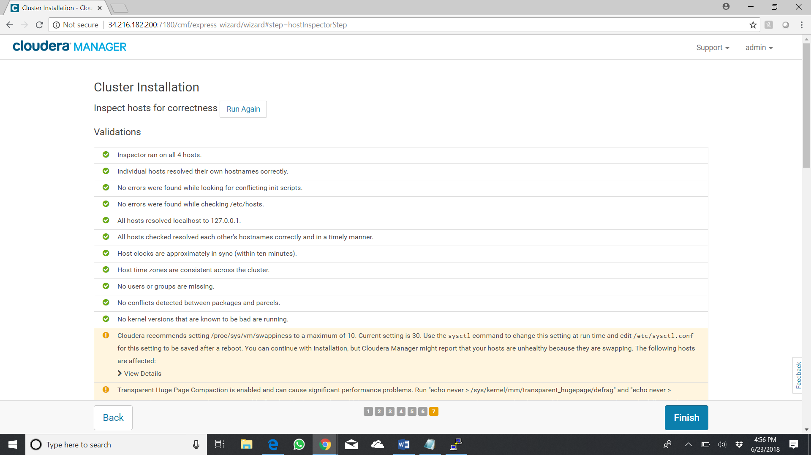

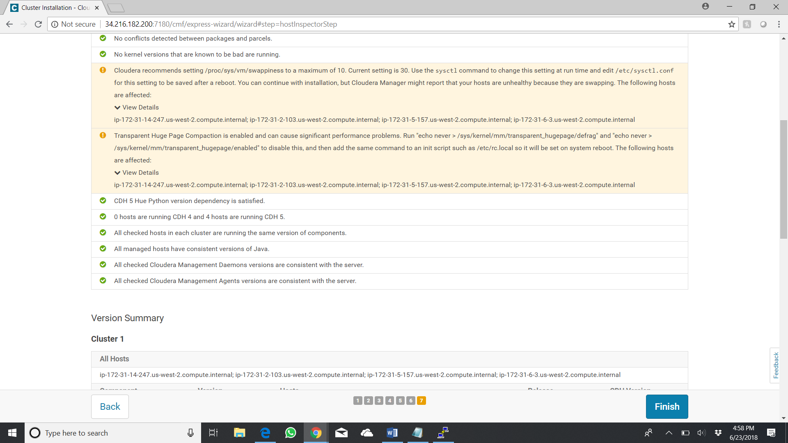

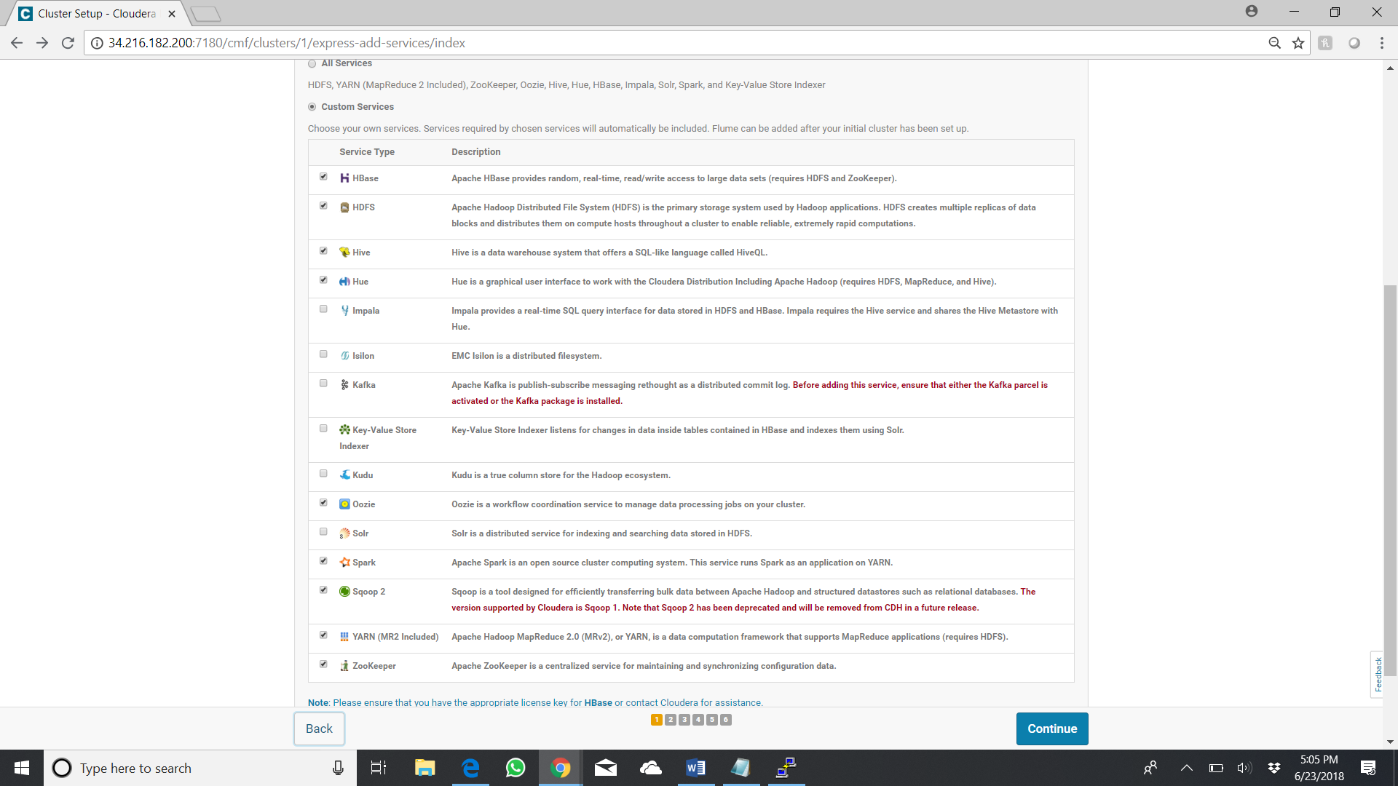

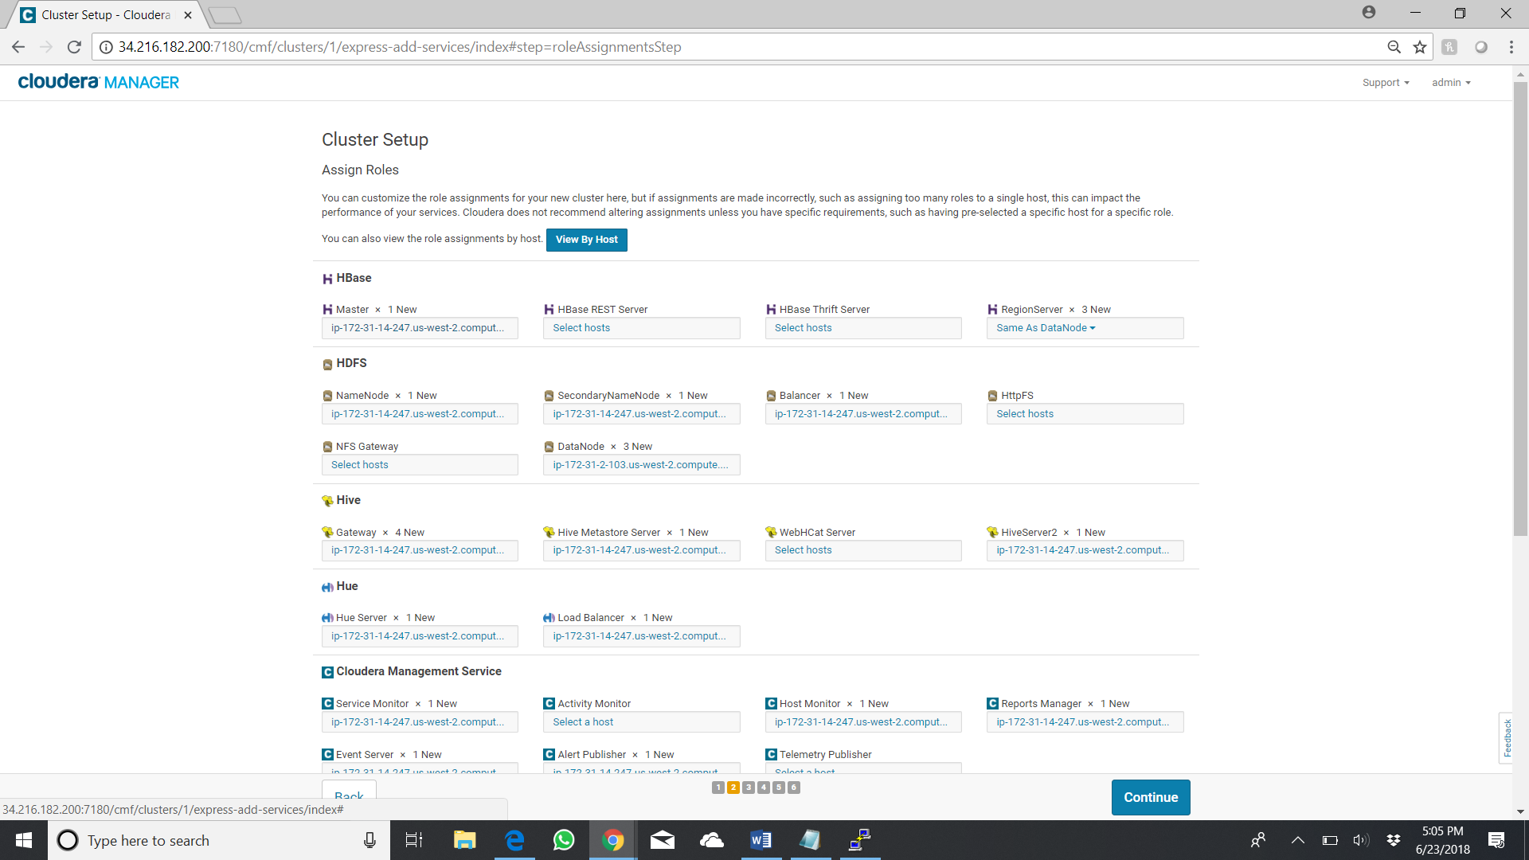

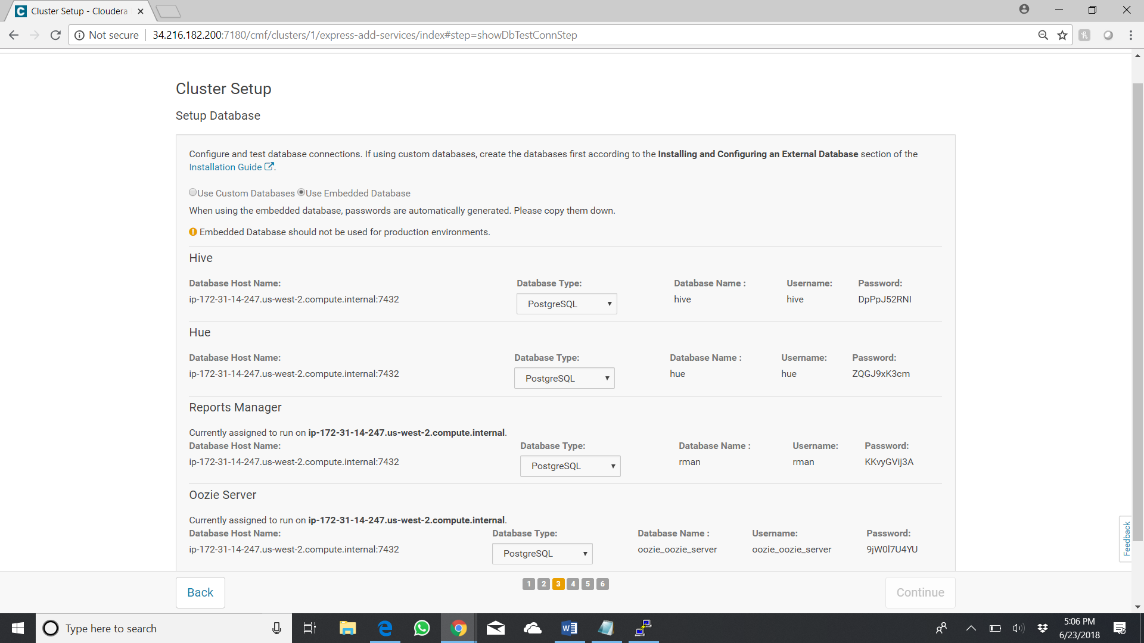

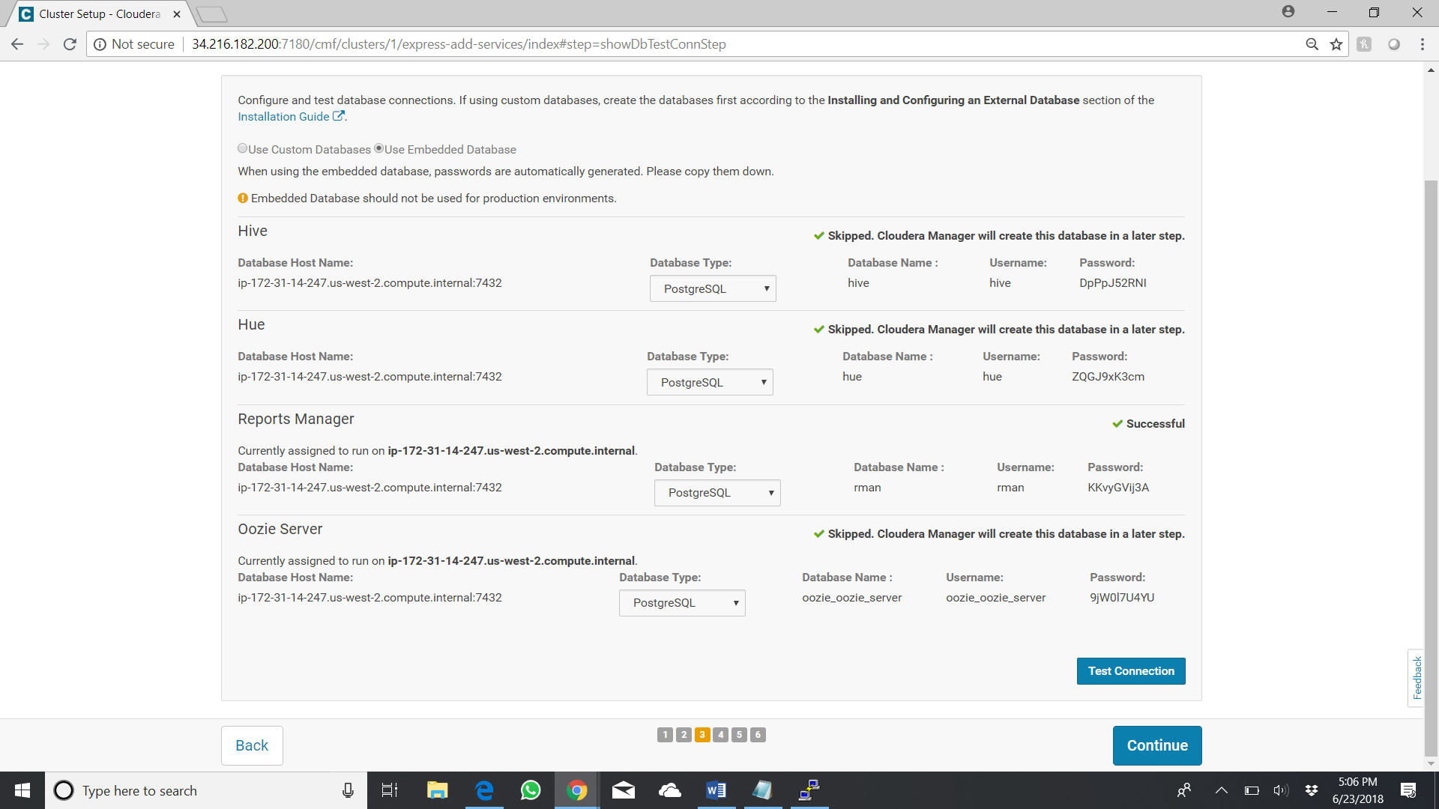

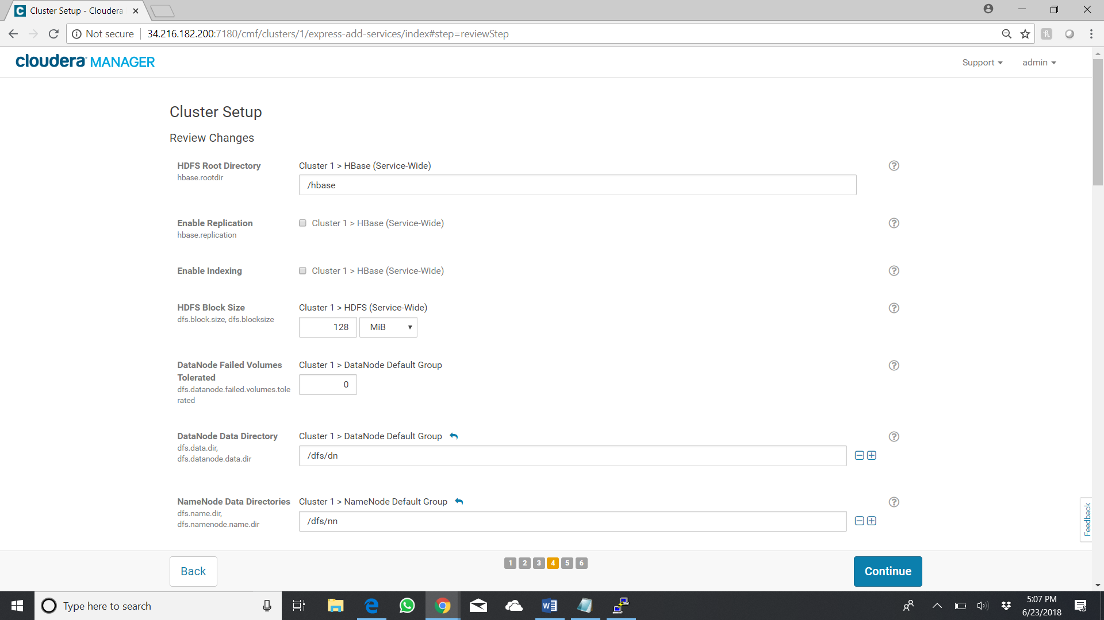

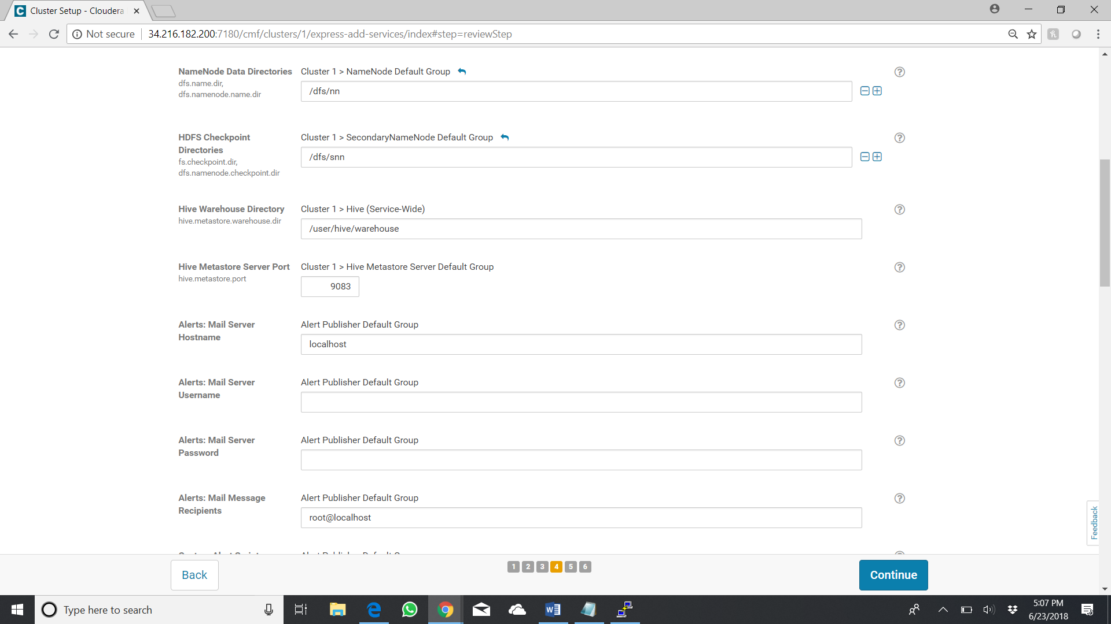

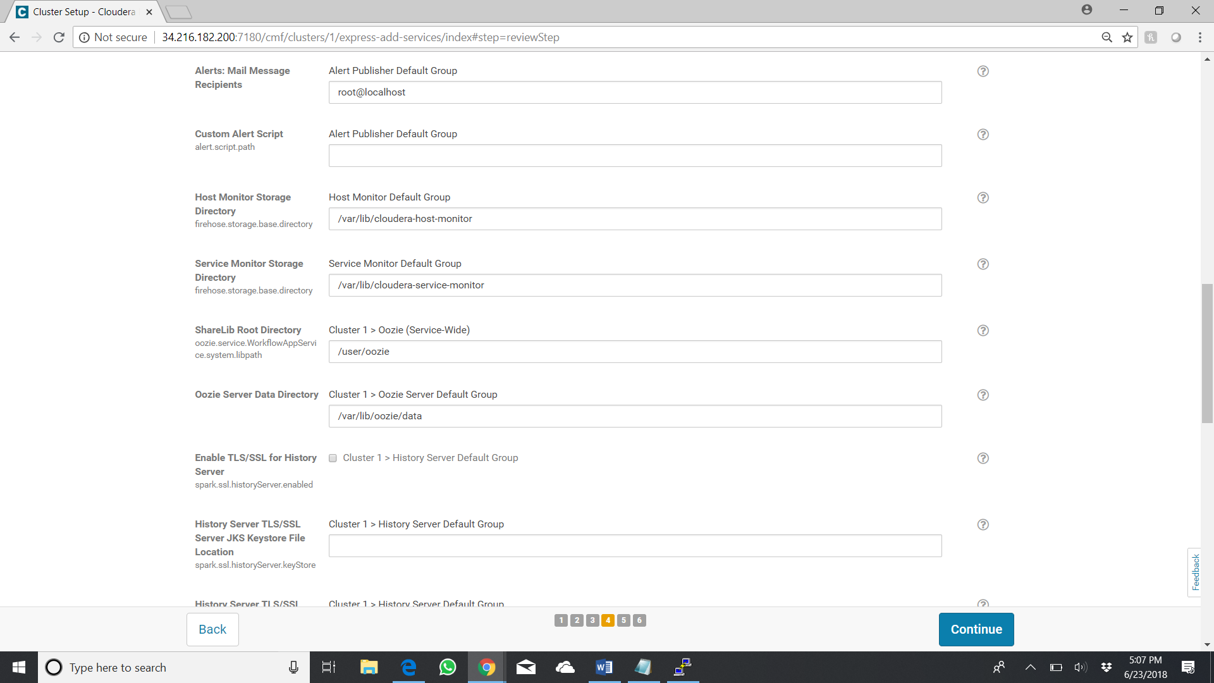

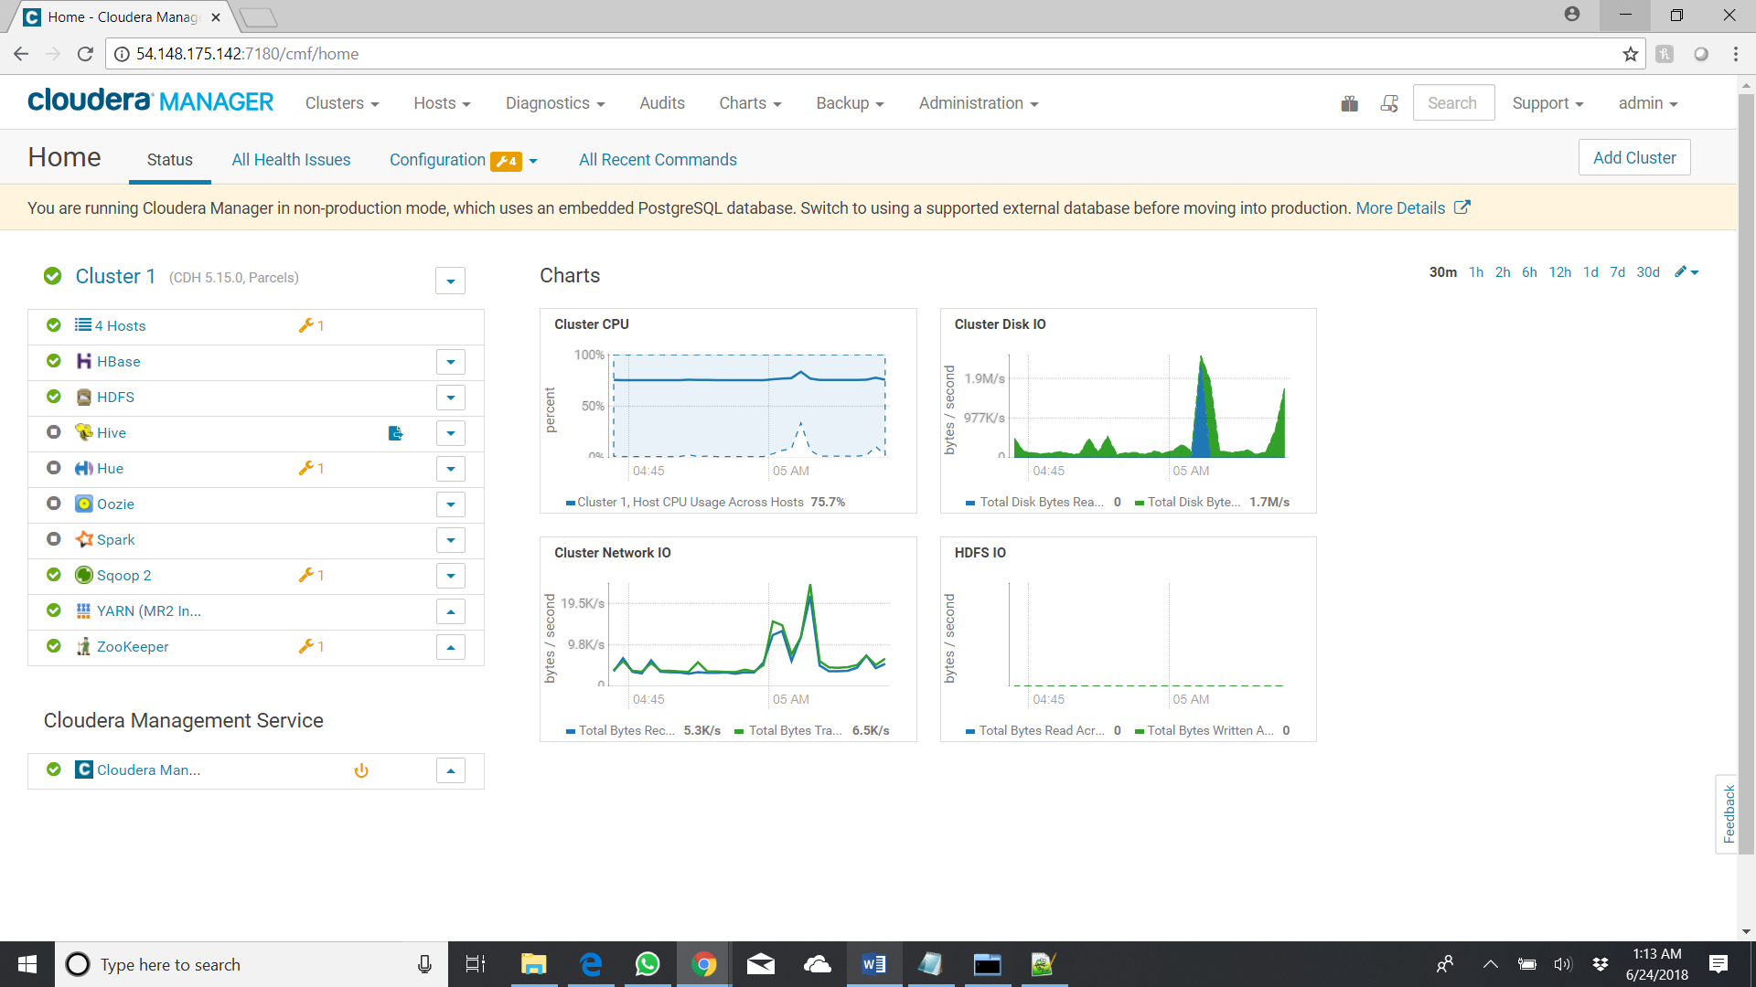

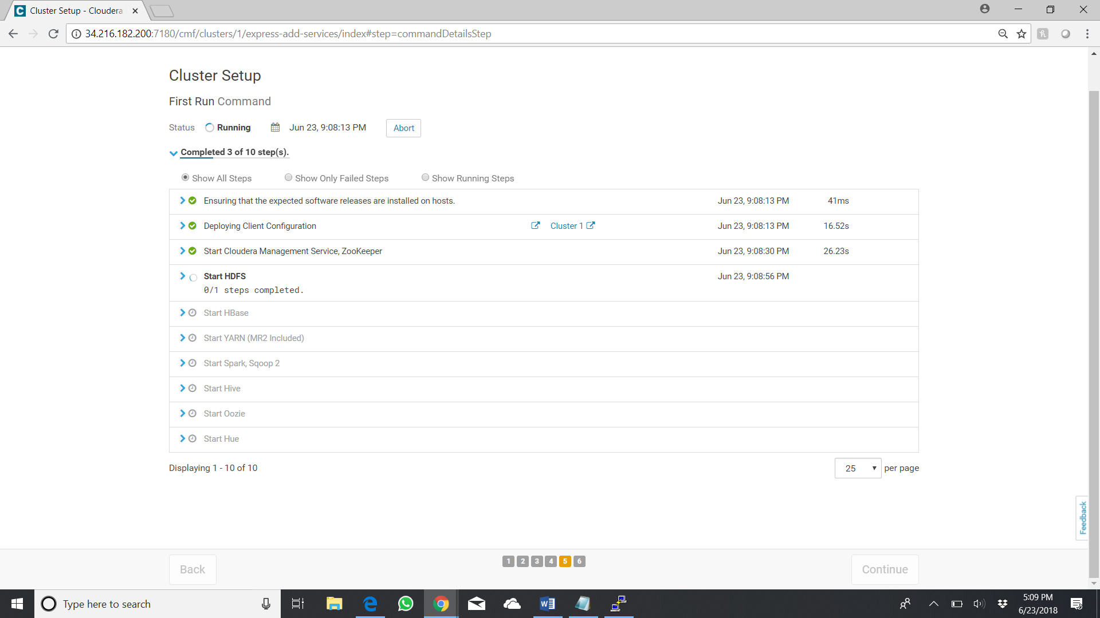

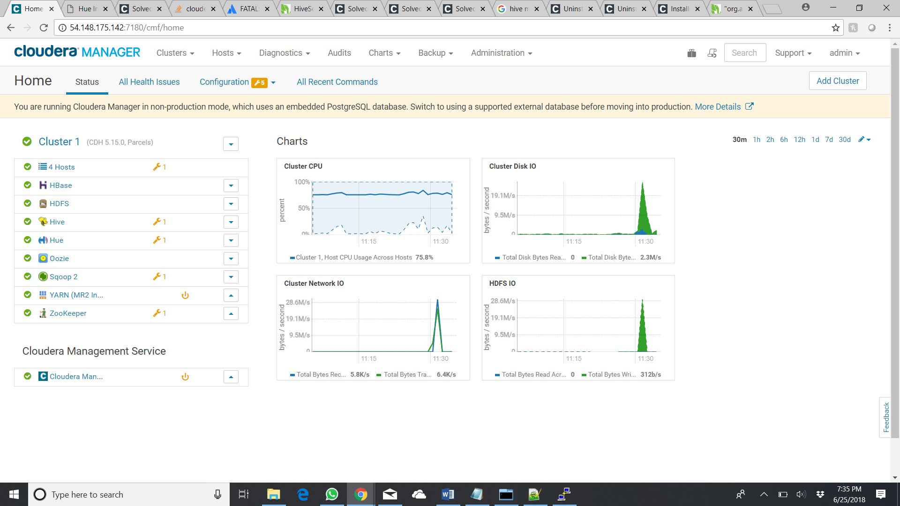

# AWS VPC SETUP

Navigate to VPC service in AWS and click Create VPC

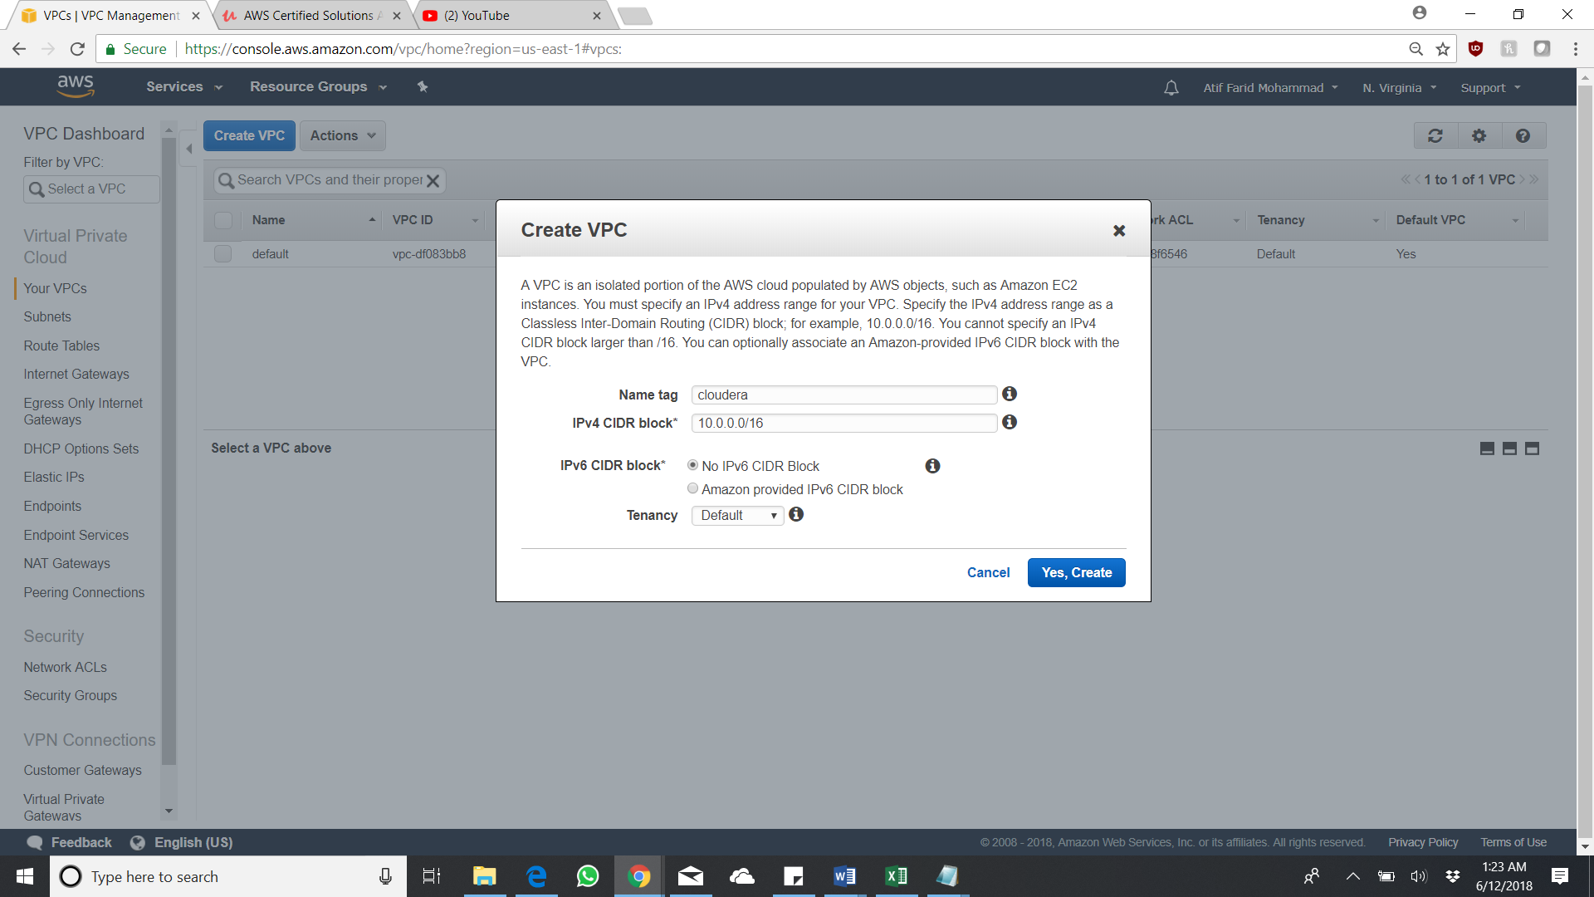

VPC Successful Created

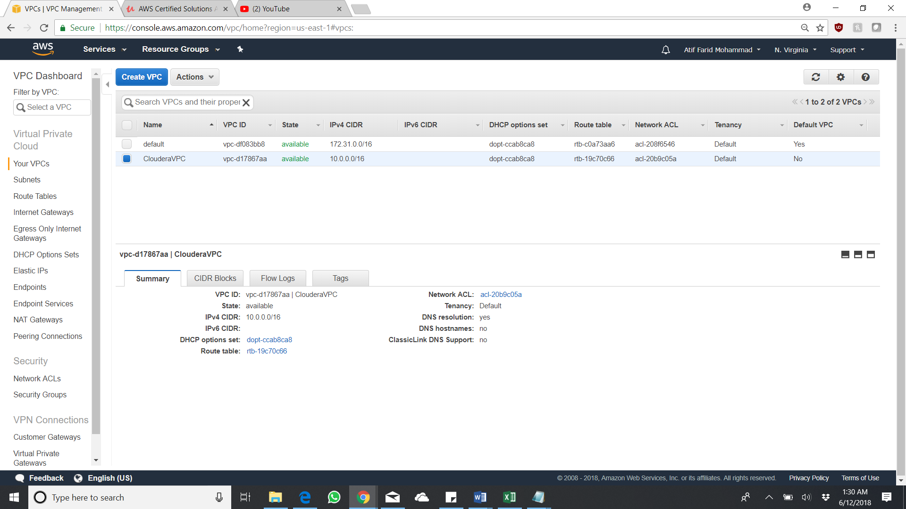

Move on to the Internet Gateway and attach the created VPC to the new Internet Gateway

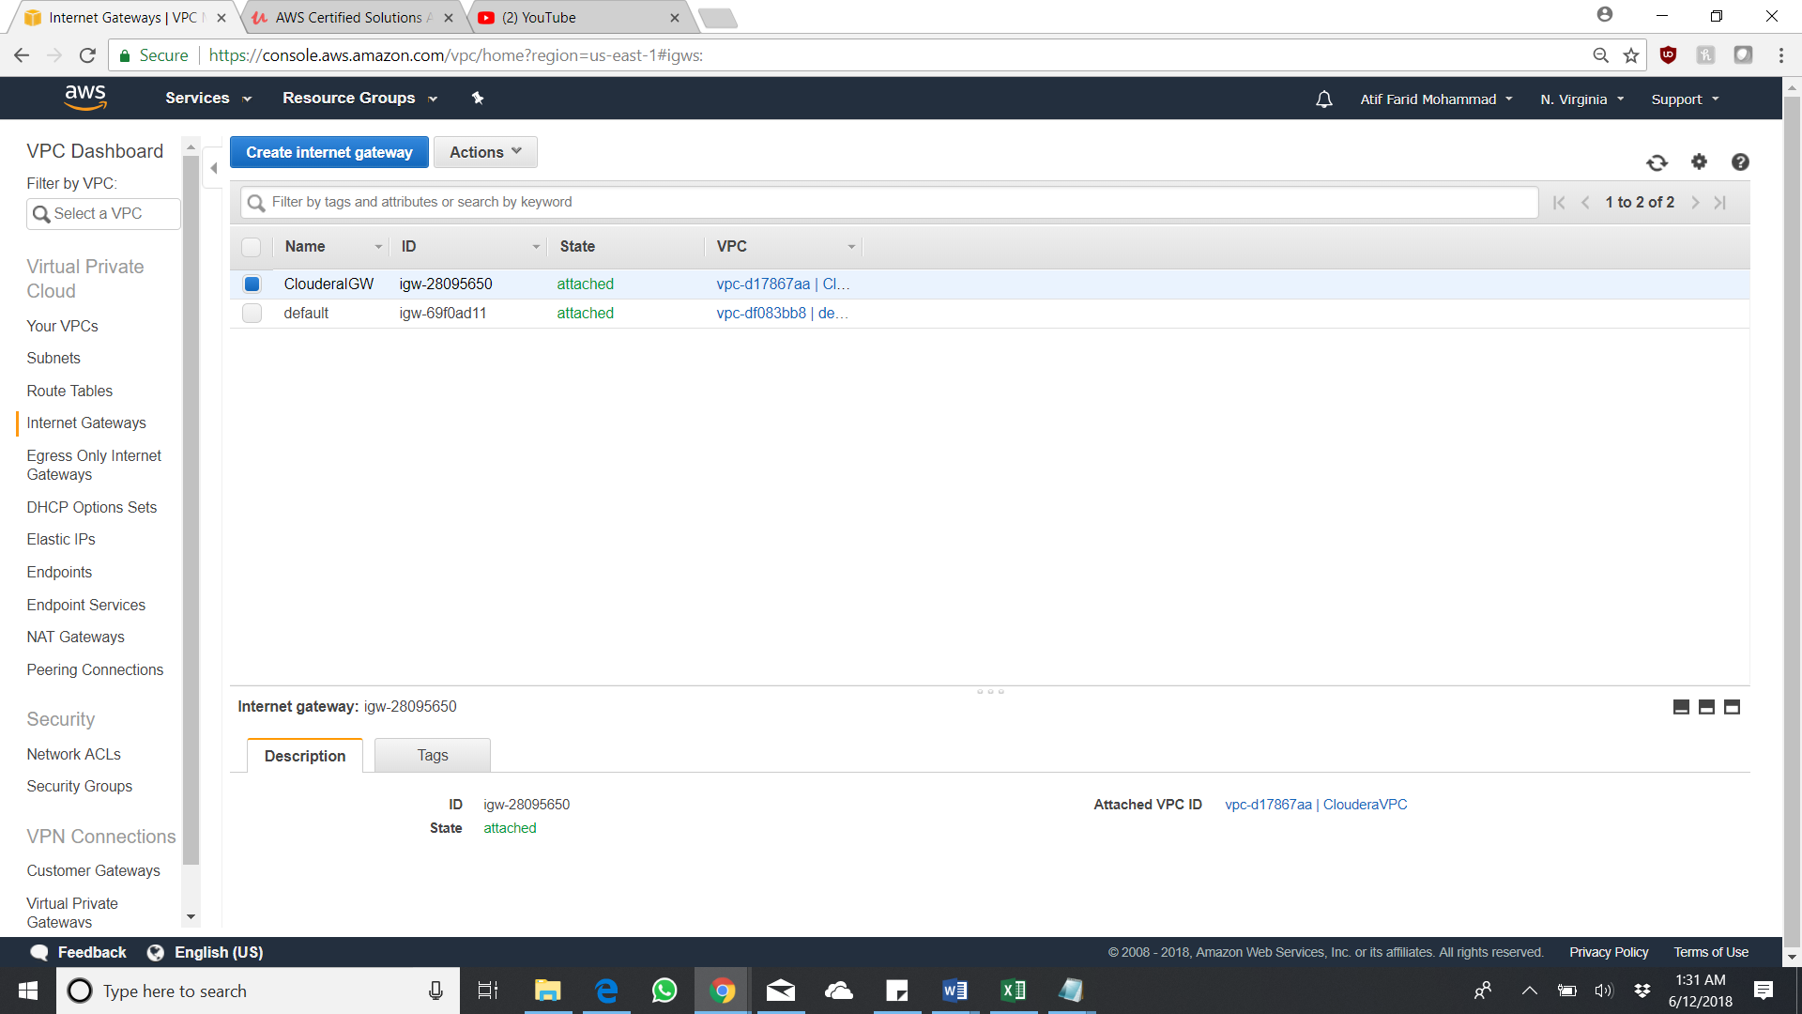

Create two Route tables on as Public and the other as Private

Public Route table should have an extra route as 0.0.0.0/0 connecting to the created internet gateway. While the private route table should not be connected.

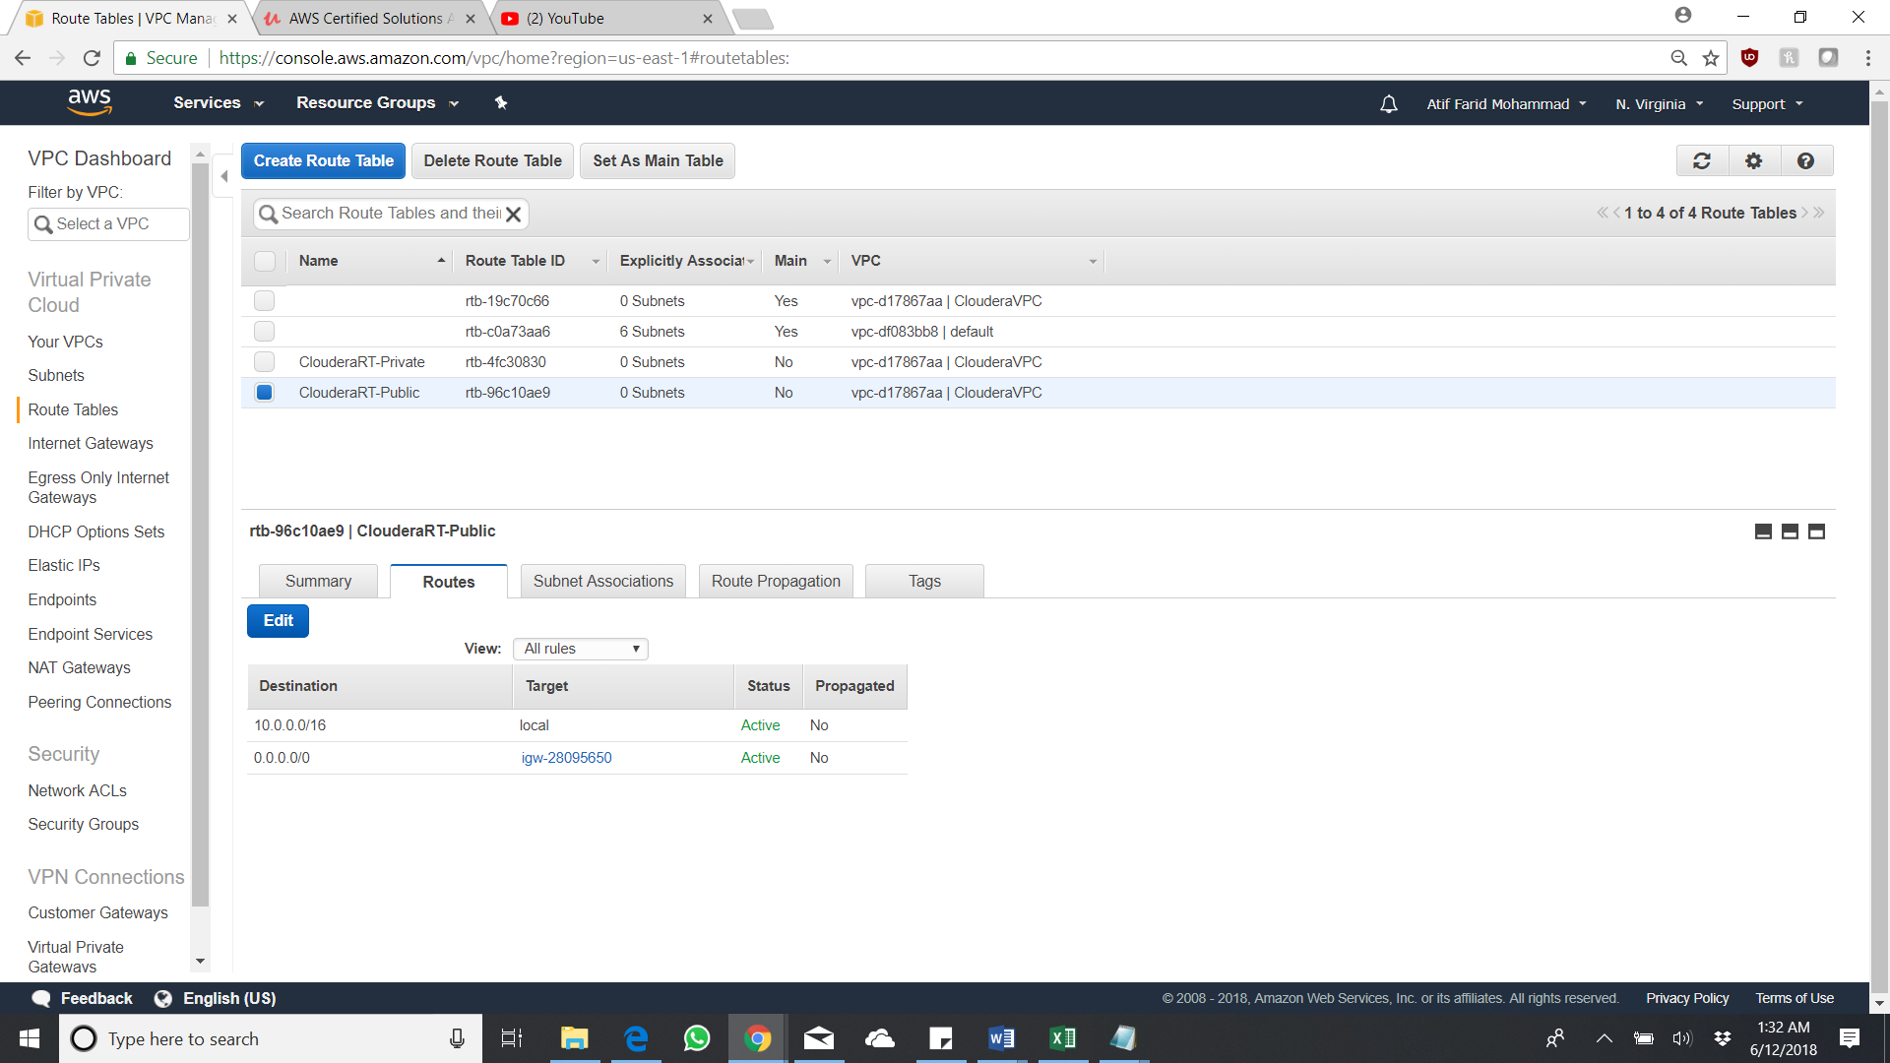

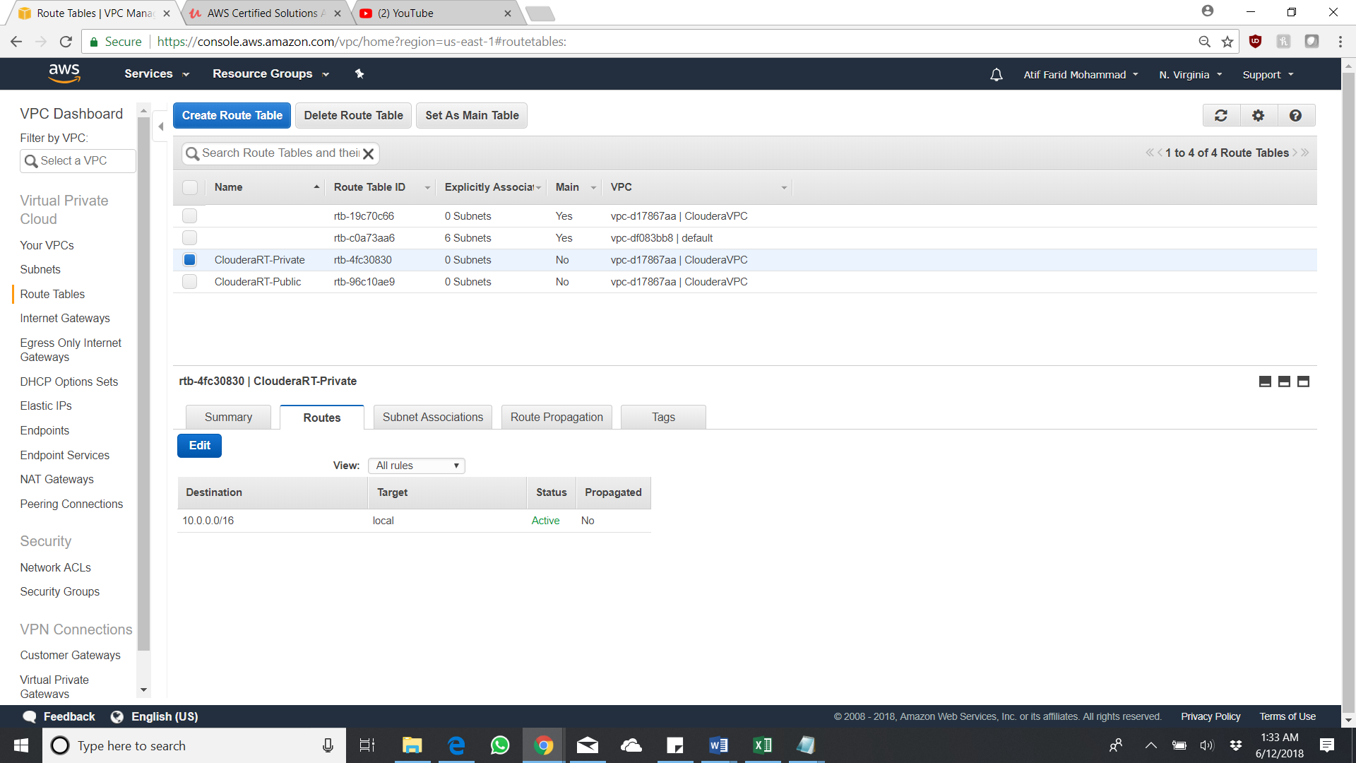

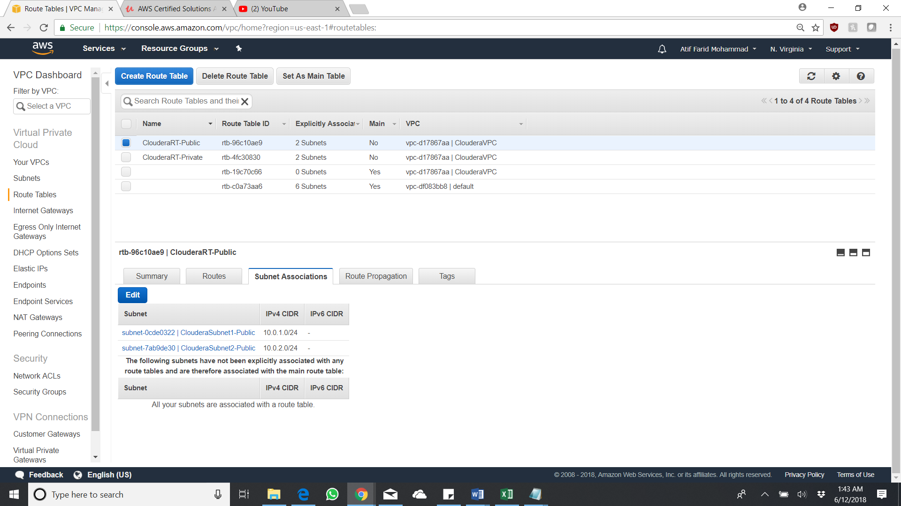

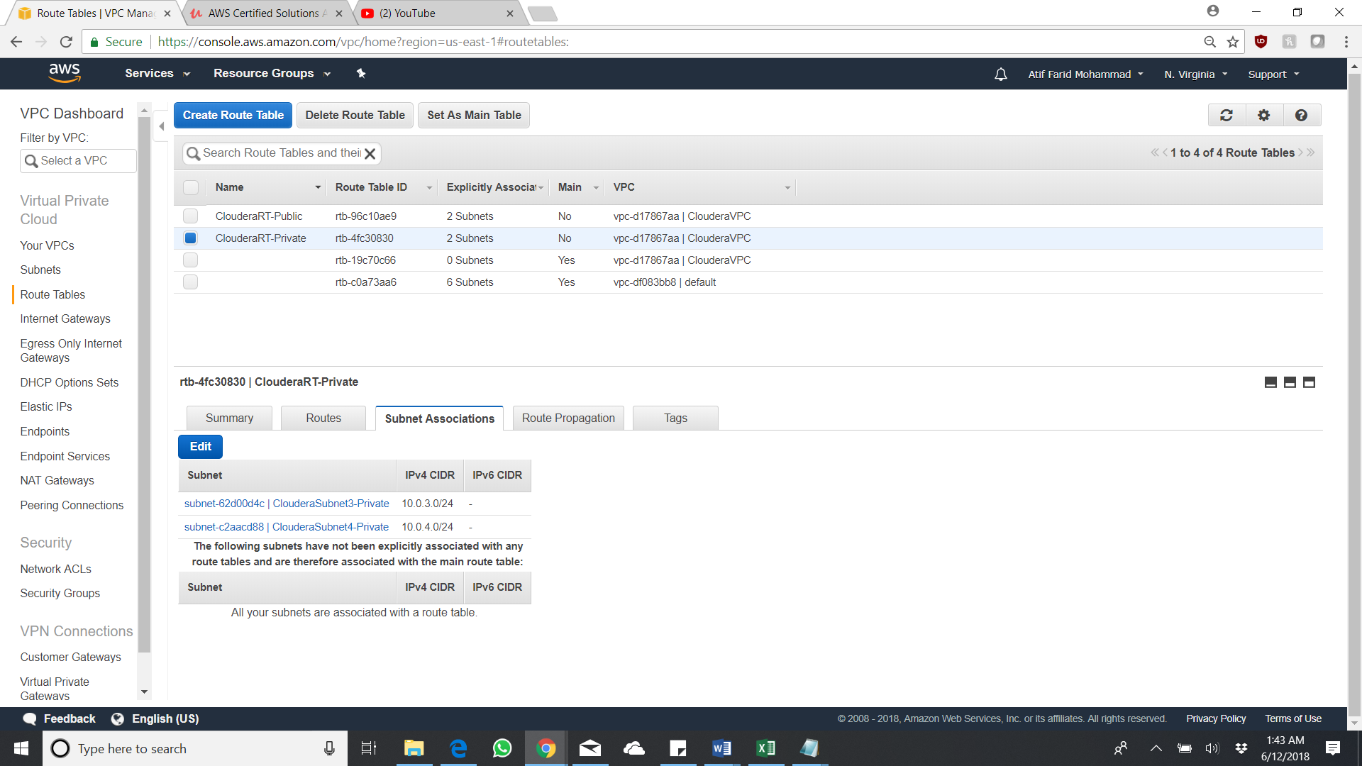

Subnet creating and we are going to create 4 subnet with two public and two private subnets which fall in a particular availability zone.

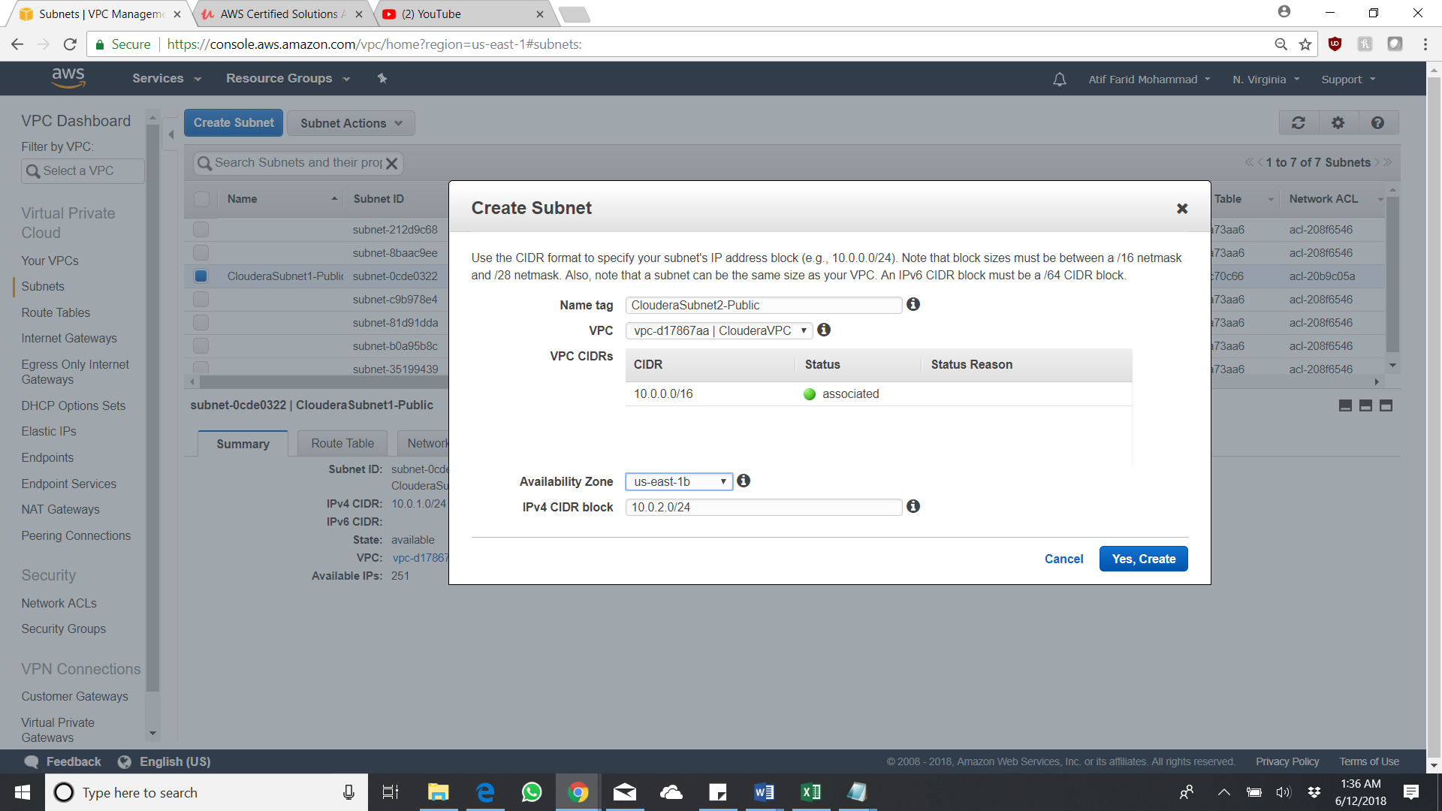

All the four subnets are created.

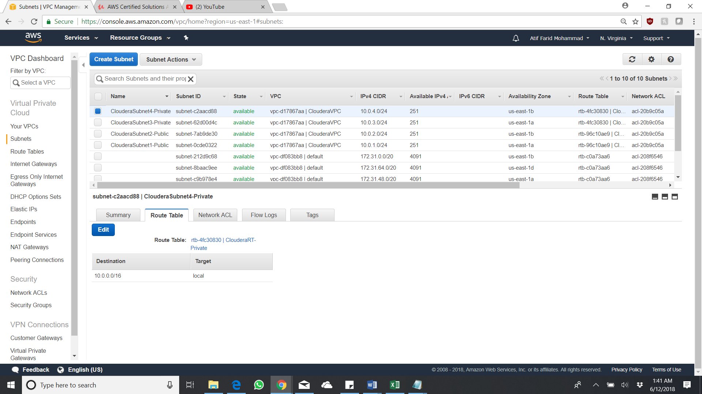

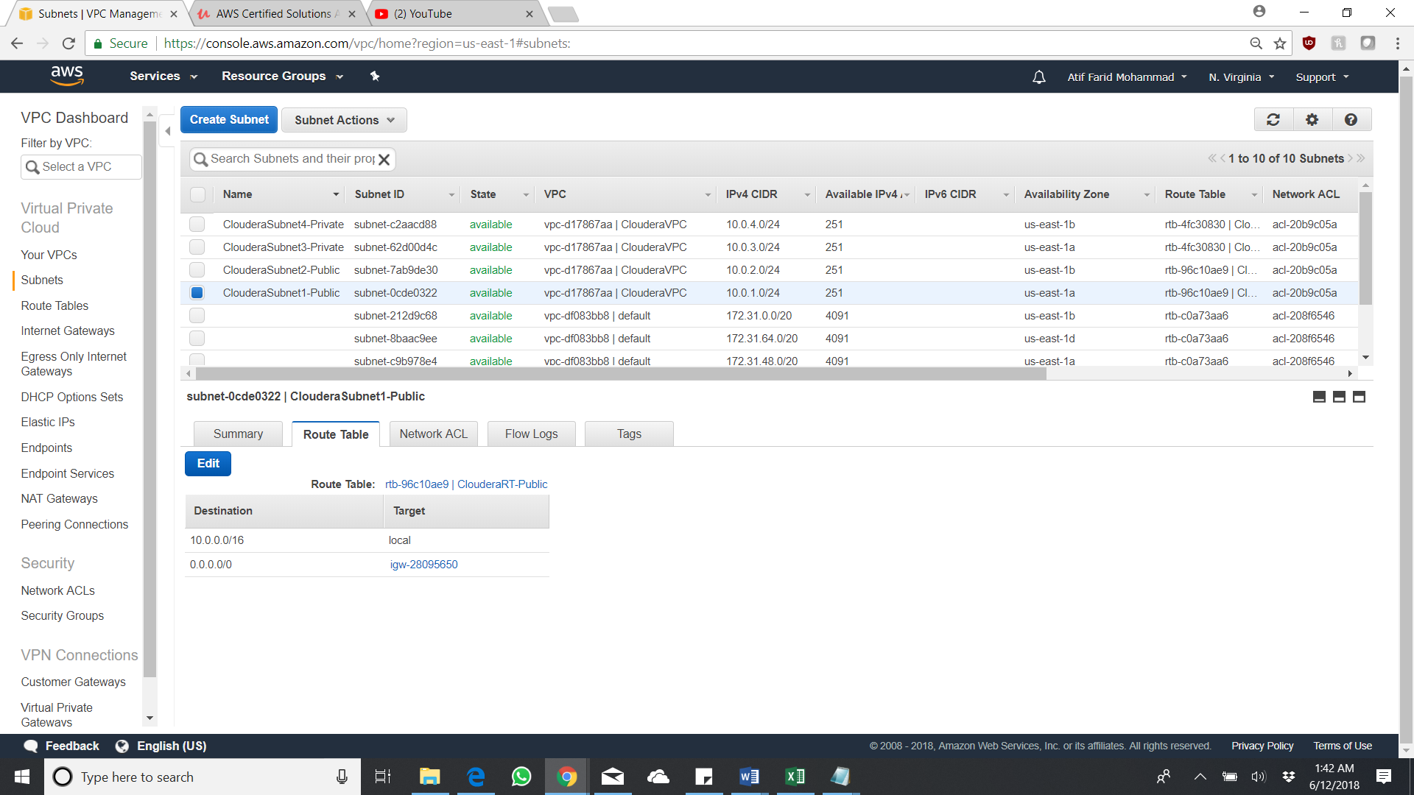

Create NACL’s and provide inbound , outbound rules

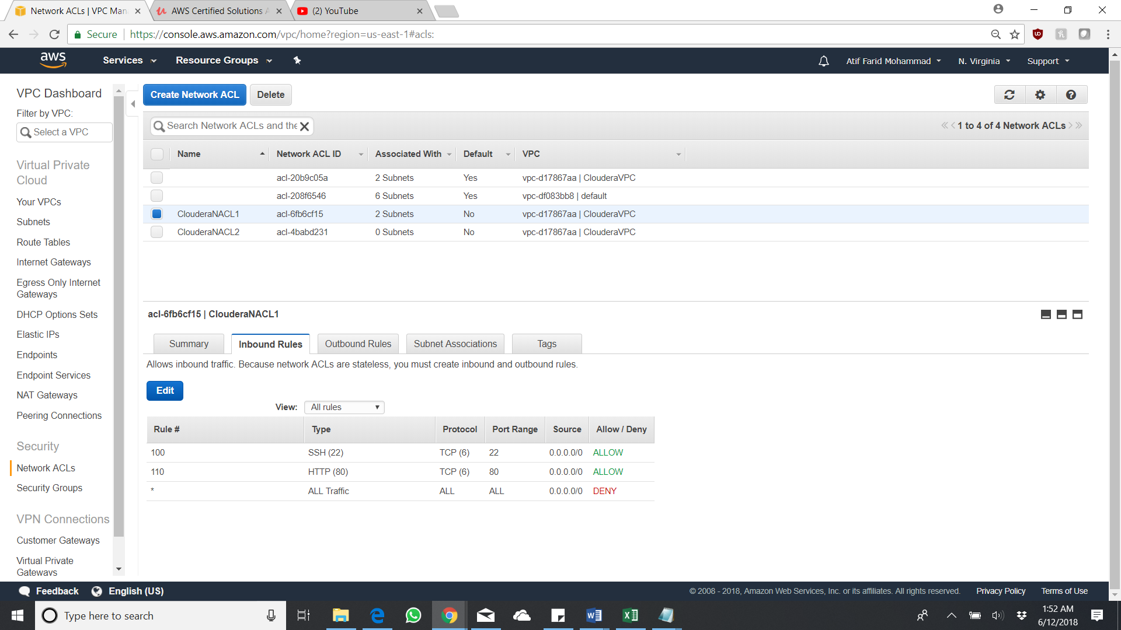 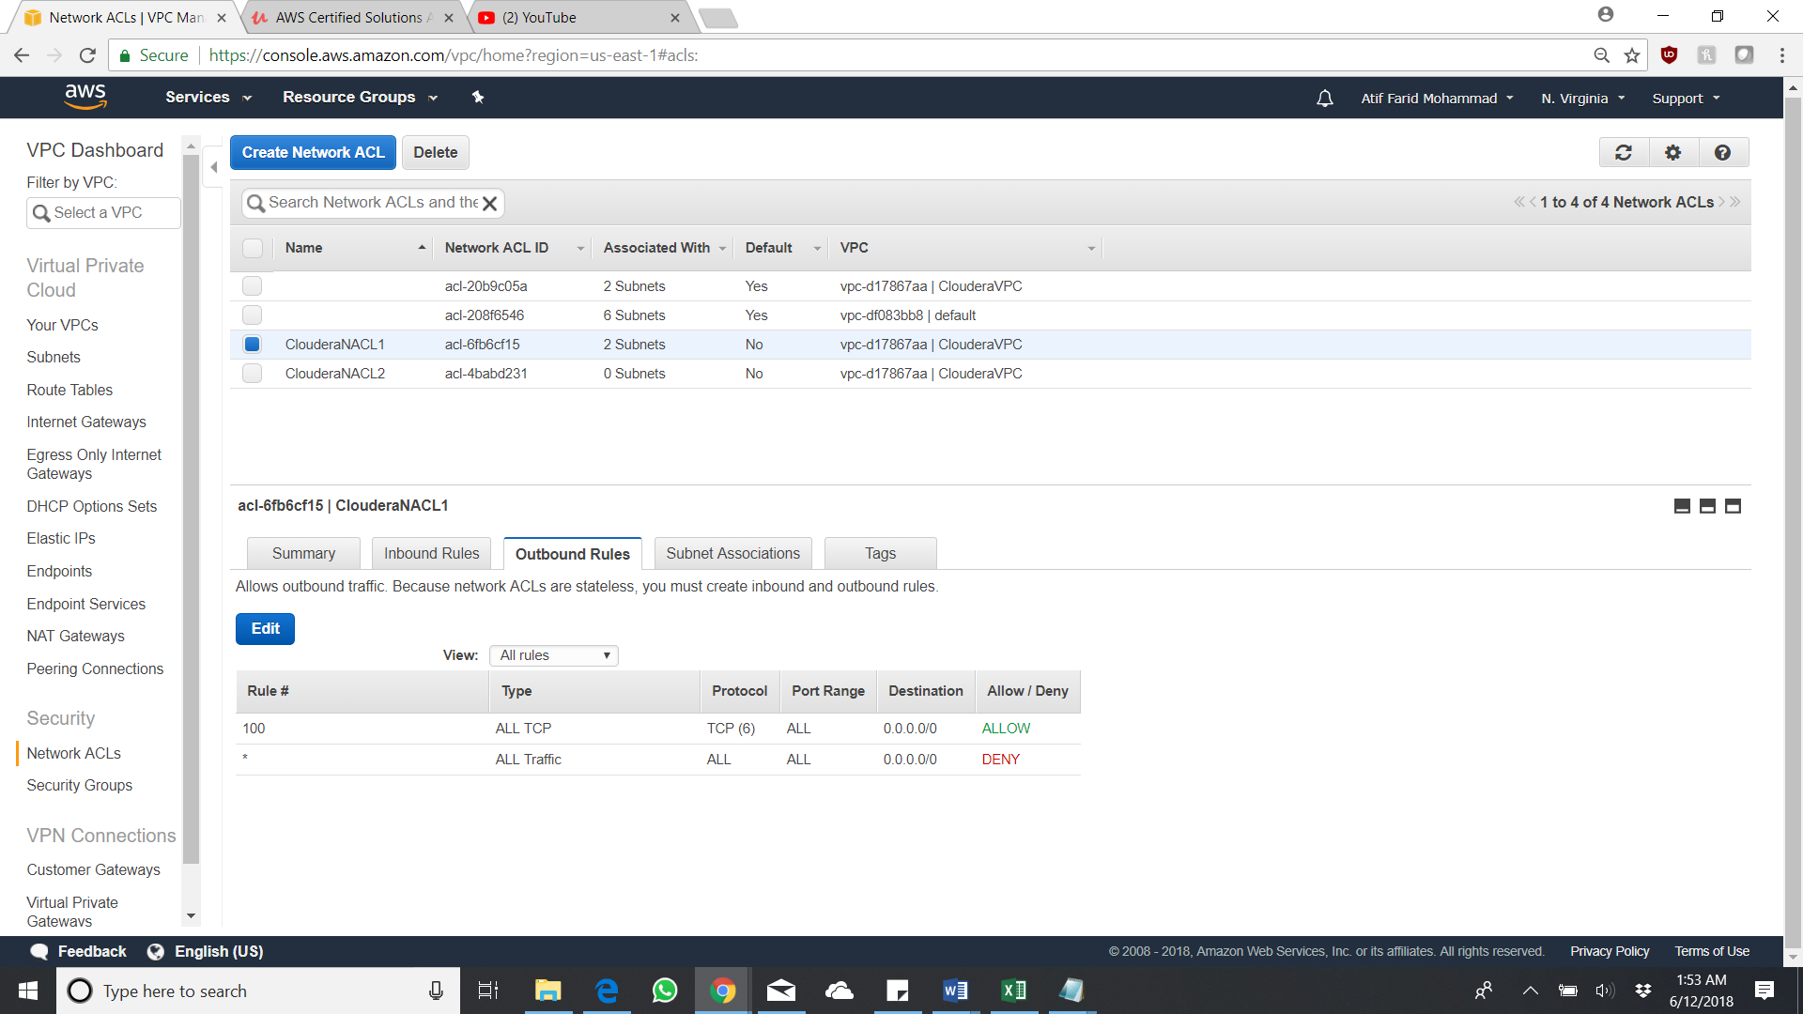

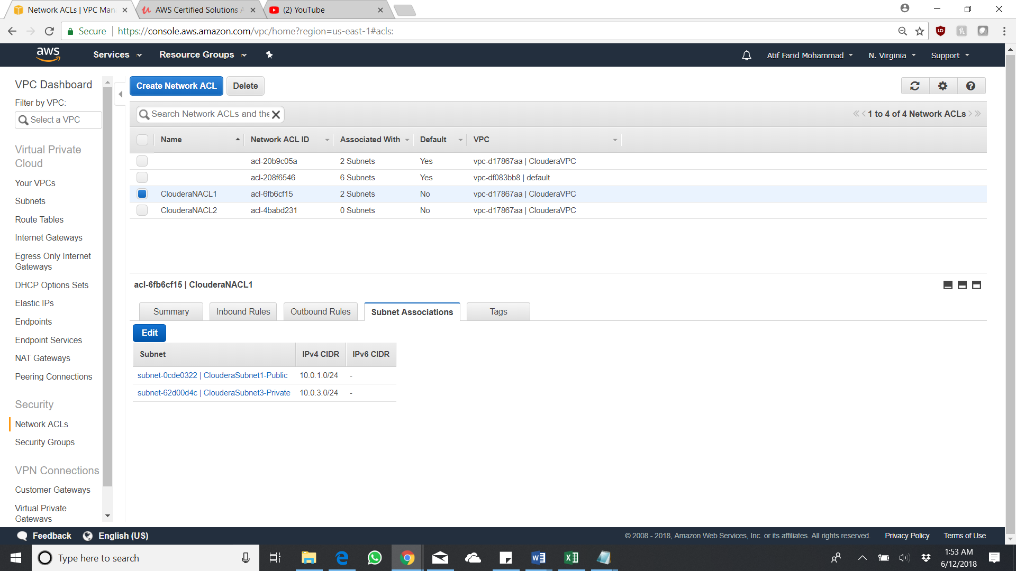

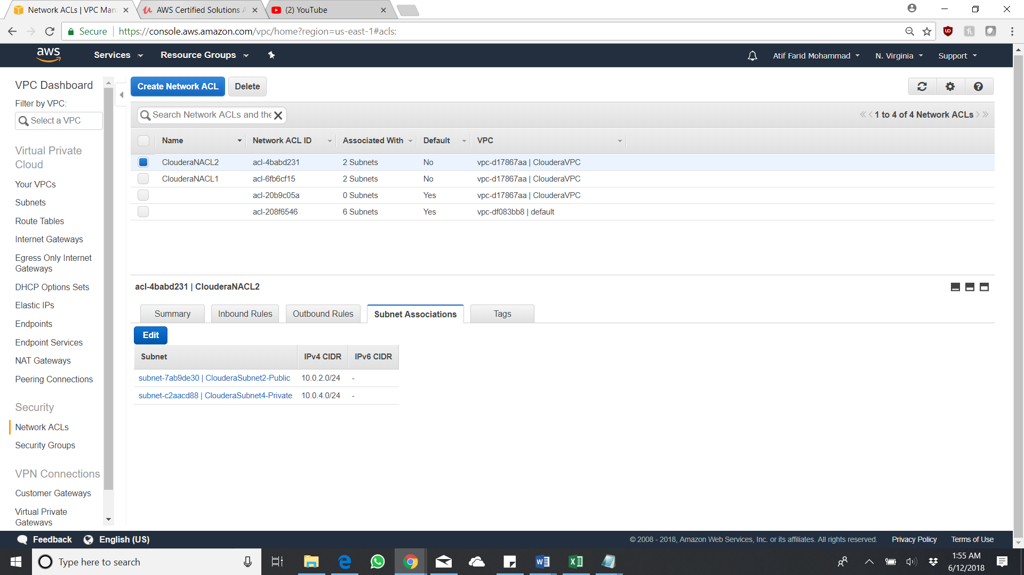

Create two security groups for subnet 1 and subnet 2 with public access

